KPR INSTITUTE OF ENGINEERING AND TECHNOLOGY
(Autonomous)
Avinashi Road, Arasur, Coimbatore - 641 407
Department of Computer Science and Engineering
U21CS501 - WEB TECHNOLOGY
ASSIGNMENT II
Student Admission Portal with Registration Form,
PHP Admin Panel and Servlet based Profile Portal
Name of the Student | KARTHICK R
Roll Number | 24CS090
Year / Semester / Section | III / V / A
Academic Year | 2026 - 2027
Date of Issue | 07.10.2026
Date of Submission | 20.10.2026
Maximum Marks | 40

CONTENTS
No. | Section
1 | Introduction
2 | Tools and Technologies Used
3 | Project Folder Structure
4 | Database Schema Script
5 | Question 1 - Student Registration Form (HTML, CSS, JavaScript)
6 | Question 2 - Admin Panel with CRUD and File Upload (PHP, MySQL)
7 | Question 3 - Student Profile Portal (Servlet, JDBC, JSP)
8 | Steps to Run the Project
9 | Testing Summary
10 | GitHub Repository
11 | Conclusion

1. Introduction
The aim of this assignment is to build the main parts of a student admission system for the college. The work is split into three parts and each question of the assignment is one part of the same project:
- Question 1: a registration form for students, built with HTML, CSS and JavaScript. Every field is checked in the browser before the form can be submitted.
- Question 2: an admin panel in PHP for the office staff. Staff can add, view, edit and delete student records and upload a profile photo, an ID proof and certificates for each student.
- Question 3: a profile portal built with Java Servlets and JSP. After logging in, staff can see all students as cards, open a profile and view or download the uploaded files.
All three parts use the same MySQL database, college_db. When a file is uploaded from the PHP admin panel, the file itself is saved in an uploads folder and its details (path, type, size and upload date) are saved in the student_files table. The Servlet portal reads the same table through JDBC and streams the file from the same folder. So whatever the admin uploads can be seen in the portal immediately, without copying anything.
Every page was tested after writing the code and the screenshots given in this document are from those test runs. The photos, ID cards and certificates used for testing are dummy files made only for this purpose.

2. Tools and Technologies Used
Table 1: Software used
Purpose | Tool / Technology
Front end (Question 1) | HTML5, CSS3 (Flexbox, media queries), JavaScript (ES6)
Server side scripting (Question 2) | PHP 8 (XAMPP), mysqli extension with prepared statements
Database | MySQL / MariaDB (bundled with XAMPP), phpMyAdmin
Java web (Question 3) | JDK 21, Jakarta Servlet 6.0 and JSP, Apache Tomcat 10.1
JDBC driver | MySQL Connector/J
Editor / IDE | Visual Studio Code, Eclipse IDE for Enterprise Java and Web Developers
Browser used for testing | Google Chrome

3. Project Folder Structure
The whole project is kept in one folder called student_portal with a sub folder for each question:
student_portal/
|-- README.md
|-- database/
| |-- college_db.sql (database schema script)
|-- q1_registration/ (Question 1)
| |-- register.html
| |-- css/style.css
| |-- js/validate.js
|-- q2_admin_php/ (Question 2 - copied to htdocs as student_admin)
| |-- db.php, functions.php, header.php, footer.php
| |-- index.php, add.php, view.php, edit.php, delete.php, delete_file.php
| |-- css/admin.css
| |-- uploads/profile/ and uploads/documents/
|-- q3_servlet_portal/ (Question 3 - Eclipse Dynamic Web Project)
|-- src/main/java/com/kpr/portal/
| |-- dao/ DBConnection.java, StudentDAO.java, UserDAO.java
| |-- model/ Student.java, StudentFile.java
| |-- servlet/ LoginServlet, LogoutServlet, StudentListServlet, ProfileServlet, FileServlet
| |-- filter/ AuthFilter.java
| |-- util/ HtmlUtil.java
|-- src/main/webapp/
|-- index.jsp
|-- css/portal.css
|-- WEB-INF/web.xml
|-- WEB-INF/lib/mysql-connector-j-x.x.x.jar
|-- WEB-INF/views/login.jsp, students.jsp, profile.jsp

4. Database Schema Script
The database has three tables. The file details are kept in a separate table instead of adding photo and document columns to the students table, because one student can have many files (a photo, an ID proof and any number of certificates). This gives a one-to-many relationship between students and student_files.
Table 2: Tables in college_db
Table | Purpose | Important columns / constraints
students | Basic details of each student | id (primary key). roll_no and email are UNIQUE, so the same student cannot be added twice.
student_files | Metadata of every uploaded file | student_id is a foreign key to students.id with ON DELETE CASCADE. Also stores file_path, file_type, file_size and upload_date. stored_name is UNIQUE.
portal_users | Login accounts for the Servlet portal | username is UNIQUE. The password is stored as a SHA-256 hash, never as plain text.

Script: database/college_db.sql
-- college_db.sql
-- Database schema for the Student Admission / Admin / Profile portal
-- Used by both the PHP admin panel (Question 2) and the Servlet portal (Question 3)
-- Run this in phpMyAdmin (SQL tab) or from the MySQL command line: mysql -u root -p < college_db.sql

CREATE DATABASE IF NOT EXISTS college_db
CHARACTER SET utf8mb4
COLLATE utf8mb4_unicode_ci;

USE college_db;

-- drop in reverse order because of the foreign key
DROP TABLE IF EXISTS student_files;
DROP TABLE IF EXISTS students;
DROP TABLE IF EXISTS portal_users;

-- 1. main student details
CREATE TABLE students (
id INT AUTO_INCREMENT PRIMARY KEY,
name VARCHAR(100) NOT NULL,
roll_no VARCHAR(20) NOT NULL UNIQUE,
email VARCHAR(100) NOT NULL UNIQUE,
phone VARCHAR(15),
course VARCHAR(50) NOT NULL,
created_at TIMESTAMP DEFAULT CURRENT_TIMESTAMP,
updated_at TIMESTAMP DEFAULT CURRENT_TIMESTAMP ON UPDATE CURRENT_TIMESTAMP
);

-- 2. metadata of every uploaded file (the file itself stays in the uploads folder)
CREATE TABLE student_files (
file_id INT AUTO_INCREMENT PRIMARY KEY,
student_id INT NOT NULL,
file_category ENUM('PROFILE', 'ID_PROOF', 'CERTIFICATE') NOT NULL,
original_name VARCHAR(255) NOT NULL, -- name of the file on the user's computer
stored_name VARCHAR(255) NOT NULL UNIQUE, -- unique name we saved it with
file_path VARCHAR(255) NOT NULL, -- path relative to the uploads folder
file_type VARCHAR(100) NOT NULL, -- MIME type, eg. image/png, application/pdf
file_size INT NOT NULL, -- size in bytes
upload_date DATETIME DEFAULT CURRENT_TIMESTAMP,
CONSTRAINT fk_files_student FOREIGN KEY (student_id)
REFERENCES students(id) ON DELETE CASCADE -- deleting a student removes his file rows too
);

CREATE INDEX idx_files_student ON student_files(student_id);

-- 3. login table for the Servlet portal (passwords stored as SHA-256 hash, not plain text)
CREATE TABLE portal_users (
user_id INT AUTO_INCREMENT PRIMARY KEY,
username VARCHAR(50) NOT NULL UNIQUE,
password_hash CHAR(64) NOT NULL,
full_name VARCHAR(100),
role VARCHAR(20) DEFAULT 'STAFF'
);

-- default login accounts for testing
INSERT INTO portal_users (username, password_hash, full_name, role) VALUES
('admin', SHA2('Admin@123', 256), 'Portal Administrator', 'ADMIN'),
('staff1', SHA2('Staff@123', 256), 'Class Advisor - III CSE A', 'STAFF');

Default logins created by the script for the portal: admin / Admin@123 and staff1 / Staff@123.

5. Question 1 - Student Registration Form

5.1 Requirement
Create a well designed registration form for the student admission portal with name, roll number, email, course and file upload, style it with CSS (layout, colours, responsive design, styled inputs, buttons and error messages) and add client side validation in JavaScript for required fields, email format and password strength.

5.2 Design of the Form
The form is divided into three fieldsets: Personal Details, Account Password and Documents, so that it does not look like one long list of boxes. Every input is wrapped in a div with the class field, which holds the label, the input and a small tag for the error message. Because every field has the same structure, one JavaScript function can find the error tag of any input, and the code stays short.
For the layout I used Flexbox. On a laptop two fields sit side by side in one row. A media query at 640 px changes every row into a single column and makes the buttons full width, so the form is comfortable to use on a phone (Figure 7). All the colours are stored as CSS variables in :root, so the theme can be changed from one place.
The form tag has the novalidate attribute. Without it, Chrome shows its own small popups, which look different in every browser and appear only one at a time. With novalidate all the messages come from my script and appear right under the field that has the problem.

5.3 Source Code
File: q1_registration/register.html
<!DOCTYPE html>
<html lang="en">
<head>
<meta charset="UTF-8">
<!-- viewport tag is needed so the page scales properly on mobile -->
<meta name="viewport" content="width=device-width, initial-scale=1.0">
<title>Student Registration | Admission Portal</title>
<link rel="stylesheet" href="css/style.css">
</head>
<body>

<header class="top-bar">
<h1>KPR Institute of Engineering and Technology</h1>
<p>Student Admission Portal 2026 - 2027</p>
</header>

<main class="container">
<!-- novalidate turns off the browser popups, our own JS shows the messages -->
<form id="regForm" action="#" method="post" enctype="multipart/form-data" novalidate>
<h2>Student Registration Form</h2>
<p class="hint">Fields marked with <span class="req">*</span> are mandatory.</p>

<!-- Personal details -->
<fieldset>
<legend>Personal Details</legend>
<div class="row">
<div class="field">
<label for="fullName">Full Name <span class="req">*</span></label>
<input type="text" id="fullName" name="fullName" placeholder="e.g. Arun Kumar S">
<small class="error"></small>
</div>
<div class="field">
<label for="rollNo">Roll Number <span class="req">*</span></label>
<input type="text" id="rollNo" name="rollNo" placeholder="e.g. 23CS101" maxlength="9">
<small class="error"></small>
</div>
</div>

<div class="row">
<div class="field">
<label for="email">Email ID <span class="req">*</span></label>
<input type="email" id="email" name="email" placeholder="e.g. arun@gmail.com">
<small class="error"></small>
</div>
<div class="field">
<label for="mobile">Mobile Number <span class="req">*</span></label>
<input type="tel" id="mobile" name="mobile" placeholder="10 digit number" maxlength="10">
<small class="error"></small>
</div>
</div>

<div class="row">
<div class="field">
<label for="course">Course <span class="req">*</span></label>
<select id="course" name="course">
<option value="">-- Select Course --</option>
<option value="B.E. CSE">B.E. Computer Science and Engineering</option>
<option value="B.Tech IT">B.Tech Information Technology</option>
<option value="B.Tech AI&amp;DS">B.Tech AI and Data Science</option>
<option value="B.E. ECE">B.E. Electronics and Communication</option>
<option value="B.E. EEE">B.E. Electrical and Electronics</option>
<option value="B.E. MECH">B.E. Mechanical Engineering</option>
</select>
<small class="error"></small>
</div>
<div class="field">
<label>Gender <span class="req">*</span></label>
<div class="radio-group">
<label><input type="radio" name="gender" value="Male"> Male</label>
<label><input type="radio" name="gender" value="Female"> Female</label>
<label><input type="radio" name="gender" value="Other"> Other</label>
</div>
<small class="error"></small>
</div>
</div>
</fieldset>

<!-- Login details -->
<fieldset>
<legend>Account Password</legend>
<div class="row">
<div class="field">
<label for="password">Password <span class="req">*</span></label>
<input type="password" id="password" name="password" placeholder="Min. 8 characters">
<!-- strength bar, width and colour are changed from JS -->
<div class="strength"><div id="strengthBar"></div></div>
<span id="strengthText" class="strength-text"></span>
<ul class="rules" id="pwdRules">
<li data-rule="len">At least 8 characters</li>
<li data-rule="upper">One uppercase letter</li>
<li data-rule="lower">One lowercase letter</li>
<li data-rule="digit">One number</li>
<li data-rule="special">One special character (@ # $ % etc.)</li>
</ul>
<small class="error"></small>
</div>
<div class="field">
<label for="confirmPassword">Confirm Password <span class="req">*</span></label>
<input type="password" id="confirmPassword" name="confirmPassword" placeholder="Re-enter password">
<small class="error"></small>
</div>
</div>
</fieldset>

<!-- File uploads -->
<fieldset>
<legend>Documents</legend>
<div class="row">
<div class="field">
<label for="photo">Passport Size Photo <span class="req">*</span></label>
<input type="file" id="photo" name="photo" accept=".jpg,.jpeg,.png">
<span class="file-note">JPG / PNG only, maximum 2 MB</span>
<img id="photoPreview" class="preview" alt="Photo preview">
<small class="error"></small>
</div>
<div class="field">
<label for="marksheet">12th Mark Sheet (optional)</label>
<input type="file" id="marksheet" name="marksheet" accept=".pdf">
<span class="file-note">PDF only, maximum 5 MB</span>
<small class="error"></small>
</div>
</div>
</fieldset>

<div class="field">
<label class="check">
<input type="checkbox" id="agree" name="agree">
I hereby declare that the details given above are true to the best of my knowledge.
</label>
<small class="error"></small>
</div>

<div class="buttons">
<button type="reset" class="btn btn-light" id="resetBtn">Clear</button>
<button type="submit" class="btn btn-primary">Register</button>
</div>
</form>

<!-- shown only after every check passes -->
<div id="successBox" class="success-box" hidden>
<h3>Registration Successful</h3>
<p id="successMsg"></p>
<button class="btn btn-primary" id="newEntry">Register another student</button>
</div>
</main>

<footer class="foot">&copy; 2026 KPR Institute of Engineering and Technology, Coimbatore</footer>

<script src="js/validate.js"></script>
</body>
</html>

File: q1_registration/css/style.css
/* style.css - styles for the student registration page */

/* colours kept in variables so they can be changed in one place */
:root {
--primary: #1f4e8c;
--primary-dark: #163a69;
--bg: #eef2f7;
--text: #222;
--border: #c9d2de;
--error: #d93025;
--success: #188038;
}

* {
box-sizing: border-box;
margin: 0;
padding: 0;
}

body {
font-family: "Segoe UI", Arial, sans-serif;
background: var(--bg);
color: var(--text);
line-height: 1.5;
}

/* ---------- header ---------- */
.top-bar {
background: var(--primary);
color: #fff;
text-align: center;
padding: 18px 10px;
}
.top-bar h1 { font-size: 1.5rem; }
.top-bar p { font-size: 0.95rem; opacity: 0.9; }

/* ---------- form card ---------- */
.container {
max-width: 860px;
margin: 30px auto;
padding: 0 15px;
}

form, .success-box {
background: #fff;
padding: 28px 32px;
border-radius: 10px;
box-shadow: 0 4px 14px rgba(0, 0, 0, 0.08);
}

form h2 {
color: var(--primary);
margin-bottom: 4px;
}
.hint { font-size: 0.85rem; color: #666; margin-bottom: 18px; }
.req { color: var(--error); }

fieldset {
border: 1px solid var(--border);
border-radius: 8px;
padding: 14px 18px 4px;
margin-bottom: 18px;
}
legend {
padding: 0 8px;
font-weight: 600;
color: var(--primary);
}

/* two fields side by side on bigger screens */
.row {
display: flex;
gap: 20px;
}
.field {
flex: 1;
margin-bottom: 14px;
}

label {
display: block;
font-weight: 600;
font-size: 0.9rem;
margin-bottom: 5px;
}

input[type="text"],
input[type="email"],
input[type="tel"],
input[type="password"],
select {
width: 100%;
padding: 10px 12px;
border: 1.5px solid var(--border);
border-radius: 6px;
font-size: 0.95rem;
transition: border-color 0.2s, box-shadow 0.2s;
}

input:focus, select:focus {
outline: none;
border-color: var(--primary);
box-shadow: 0 0 0 3px rgba(31, 78, 140, 0.15);
}

input[type="file"] { font-size: 0.9rem; width: 100%; }
.file-note { display: block; font-size: 0.78rem; color: #777; margin-top: 3px; }

.radio-group { display: flex; gap: 18px; padding-top: 8px; }
.radio-group label, .check { font-weight: normal; display: flex; align-items: center; gap: 6px; }
.check { align-items: flex-start; font-size: 0.9rem; }
.check input { margin-top: 4px; }

/* ---------- validation states (classes added by JS) ---------- */
.field.invalid input,
.field.invalid select { border-color: var(--error); }
.field.valid input,
.field.valid select { border-color: var(--success); }

.error {
display: block;
color: var(--error);
font-size: 0.8rem;
min-height: 1em;
margin-top: 3px;
}

/* ---------- password strength ---------- */
.strength {
height: 6px;
background: #e3e3e3;
border-radius: 3px;
margin-top: 8px;
overflow: hidden;
}
#strengthBar {
height: 100%;
width: 0;
transition: width 0.3s, background 0.3s;
}
.strength-text { font-size: 0.8rem; font-weight: 600; }

.rules { list-style: none; font-size: 0.78rem; color: #888; margin-top: 4px; }
.rules li::before { content: "\2717 "; color: var(--error); } /* cross mark */
.rules li.ok { color: var(--success); }
.rules li.ok::before { content: "\2713 "; color: var(--success); } /* tick mark */

/* ---------- photo preview ---------- */
.preview {
display: none;
width: 90px;
height: 110px;
object-fit: cover;
border: 1px solid var(--border);
border-radius: 4px;
margin-top: 8px;
}

/* ---------- buttons ---------- */
.buttons { display: flex; justify-content: flex-end; gap: 12px; margin-top: 10px; }

.btn {
padding: 10px 26px;
border: none;
border-radius: 6px;
font-size: 0.95rem;
font-weight: 600;
cursor: pointer;
}
.btn-primary { background: var(--primary); color: #fff; }
.btn-primary:hover { background: var(--primary-dark); }
.btn-light { background: #e4e8ee; color: #333; }
.btn-light:hover { background: #d4d9e0; }

/* ---------- success message ---------- */
.success-box { text-align: center; border-top: 5px solid var(--success); }
.success-box h3 { color: var(--success); margin-bottom: 8px; }
.success-box p { margin-bottom: 16px; }

.foot { text-align: center; font-size: 0.8rem; color: #777; padding: 10px 0 25px; }

/* ---------- responsive part: stack fields on small screens ---------- */
@media (max-width: 640px) {
.row { flex-direction: column; gap: 0; }
form, .success-box { padding: 20px 16px; }
.top-bar h1 { font-size: 1.15rem; }
.buttons { flex-direction: column-reverse; }
.btn { width: 100%; }
}

File: q1_registration/js/validate.js
// validate.js - client side validation for the student registration form
// Every field is checked while typing (live) and once again when Register is clicked.

const form = document.getElementById("regForm");

// limits for uploaded files
const MAX_PHOTO_SIZE = 2 * 1024 * 1024; // 2 MB
const MAX_PDF_SIZE = 5 * 1024 * 1024; // 5 MB

// ---------- helper functions to show / clear messages ----------
function setError(element, message) {
const field = element.closest(".field");
field.classList.add("invalid");
field.classList.remove("valid");
field.querySelector(".error").textContent = message;
return false;
}

function setValid(element) {
const field = element.closest(".field");
field.classList.remove("invalid");
field.classList.add("valid");
field.querySelector(".error").textContent = "";
return true;
}

// ---------- individual field checks ----------
function checkName() {
const name = form.fullName.value.trim();
if (name === "") return setError(form.fullName, "Name is required");
if (!/^[A-Za-z. ]{3,50}$/.test(name))
return setError(form.fullName, "Only letters, dot and space allowed (3 to 50 characters)");
return setValid(form.fullName);
}

function checkRollNo() {
// converting to upper case so that 23cs101 and 23CS101 are treated the same
const roll = form.rollNo.value.trim().toUpperCase();
form.rollNo.value = roll;
if (roll === "") return setError(form.rollNo, "Roll number is required");
// format: 2 digit year + 2 to 4 letter dept code + 3 digit number, eg. 23CS101
if (!/^[0-9]{2}[A-Z]{2,4}[0-9]{3}$/.test(roll))
return setError(form.rollNo, "Invalid format. Example: 23CS101");
return setValid(form.rollNo);
}

function checkEmail() {
const email = form.email.value.trim();
if (email === "") return setError(form.email, "Email is required");
const pattern = /^[a-zA-Z0-9._%+-]+@[a-zA-Z0-9.-]+\.[a-zA-Z]{2,}$/;
if (!pattern.test(email)) return setError(form.email, "Enter a valid email (eg. name@gmail.com)");
return setValid(form.email);
}

function checkMobile() {
const mobile = form.mobile.value.trim();
if (mobile === "") return setError(form.mobile, "Mobile number is required");
// Indian mobile numbers are 10 digits and start with 6, 7, 8 or 9
if (!/^[6-9][0-9]{9}$/.test(mobile))
return setError(form.mobile, "Enter a valid 10 digit mobile number");
return setValid(form.mobile);
}

function checkCourse() {
if (form.course.value === "") return setError(form.course, "Please select a course");
return setValid(form.course);
}

function checkGender() {
const picked = form.querySelector('input[name="gender"]:checked');
const firstRadio = form.querySelector('input[name="gender"]');
if (!picked) return setError(firstRadio, "Please select gender");
return setValid(firstRadio);
}

// ---------- password strength ----------
// returns which rules are satisfied, used by both the meter and the final check
function passwordRules(pwd) {
return {
len: pwd.length >= 8,
upper: /[A-Z]/.test(pwd),
lower: /[a-z]/.test(pwd),
digit: /[0-9]/.test(pwd),
special: /[^A-Za-z0-9]/.test(pwd)
};
}

function updateStrengthMeter() {
const pwd = form.password.value;
const rules = passwordRules(pwd);
const score = Object.values(rules).filter(Boolean).length; // 0 to 5

// tick / cross in the rules list
document.querySelectorAll("#pwdRules li").forEach(li => {
li.classList.toggle("ok", rules[li.dataset.rule]);
});

const bar = document.getElementById("strengthBar");
const text = document.getElementById("strengthText");
let label = "", colour = "";

if (pwd.length === 0) { label = ""; colour = "transparent"; }
else if (score <= 2) { label = "Weak"; colour = "#d93025"; }
else if (score <= 4) { label = "Medium"; colour = "#f29900"; }
else { label = "Strong"; colour = "#188038"; }

bar.style.width = (score * 20) + "%";
bar.style.background = colour;
text.textContent = label ? "Strength: " + label : "";
text.style.color = colour;
}

function checkPassword() {
const pwd = form.password.value;
if (pwd === "") return setError(form.password, "Password is required");
const rules = passwordRules(pwd);
// all five rules must pass, otherwise password is not strong enough
if (!Object.values(rules).every(Boolean))
return setError(form.password, "Password is not strong enough, see the rules above");
return setValid(form.password);
}

function checkConfirmPassword() {
const cpwd = form.confirmPassword.value;
if (cpwd === "") return setError(form.confirmPassword, "Please confirm your password");
if (cpwd !== form.password.value) return setError(form.confirmPassword, "Passwords do not match");
return setValid(form.confirmPassword);
}

// ---------- file checks ----------
function checkPhoto() {
const file = form.photo.files[0];
const preview = document.getElementById("photoPreview");
preview.style.display = "none";

if (!file) return setError(form.photo, "Please upload your photo");
if (!["image/jpeg", "image/png"].includes(file.type))
return setError(form.photo, "Only JPG or PNG images are allowed");
if (file.size > MAX_PHOTO_SIZE)
return setError(form.photo, "Photo size should be less than 2 MB");

// show a small preview of the selected photo
preview.src = URL.createObjectURL(file);
preview.style.display = "block";
return setValid(form.photo);
}

function checkMarksheet() {
const file = form.marksheet.files[0];
if (!file) { // optional field, so empty is fine
form.marksheet.closest(".field").classList.remove("invalid", "valid");
form.marksheet.closest(".field").querySelector(".error").textContent = "";
return true;
}
if (file.type !== "application/pdf" && !file.name.toLowerCase().endsWith(".pdf"))
return setError(form.marksheet, "Mark sheet must be a PDF file");
if (file.size > MAX_PDF_SIZE)
return setError(form.marksheet, "PDF size should be less than 5 MB");
return setValid(form.marksheet);
}

function checkAgree() {
if (!form.agree.checked) return setError(form.agree, "You must accept the declaration");
return setValid(form.agree);
}

// ---------- live validation while the user types ----------
form.fullName.addEventListener("input", checkName);
form.rollNo.addEventListener("blur", checkRollNo);
form.email.addEventListener("input", checkEmail);
form.mobile.addEventListener("input", checkMobile);
form.course.addEventListener("change", checkCourse);
form.querySelectorAll('input[name="gender"]').forEach(r => r.addEventListener("change", checkGender));
form.password.addEventListener("input", () => {
updateStrengthMeter();
checkPassword();
if (form.confirmPassword.value !== "") checkConfirmPassword();
});
form.confirmPassword.addEventListener("input", checkConfirmPassword);
form.photo.addEventListener("change", checkPhoto);
form.marksheet.addEventListener("change", checkMarksheet);
form.agree.addEventListener("change", checkAgree);

// ---------- final check on submit ----------
form.addEventListener("submit", function (event) {
event.preventDefault();

// run every check (not using && because we want all errors to show at once)
const results = [
checkName(), checkRollNo(), checkEmail(), checkMobile(), checkCourse(),
checkGender(), checkPassword(), checkConfirmPassword(), checkPhoto(),
checkMarksheet(), checkAgree()
];

if (results.includes(false)) {
// take the user to the first wrong field
const firstBad = form.querySelector(".field.invalid input, .field.invalid select");
if (firstBad) firstBad.focus();
return;
}

// everything is fine. In the full project the data is sent to the server here (form.submit()).
form.hidden = true;
document.getElementById("successMsg").textContent =
"Thank you " + form.fullName.value.trim() + " (" + form.rollNo.value +
"). Your registration for " + form.course.value + " has been received.";
document.getElementById("successBox").hidden = false;
});

// clearing the form should also clear the coloured borders and messages
form.addEventListener("reset", function () {
setTimeout(() => {
form.querySelectorAll(".field").forEach(f => {
f.classList.remove("invalid", "valid");
const err = f.querySelector(".error");
if (err) err.textContent = "";
});
updateStrengthMeter();
document.getElementById("photoPreview").style.display = "none";
}, 0);
});

document.getElementById("newEntry").addEventListener("click", function () {
form.reset();
form.hidden = false;
document.getElementById("successBox").hidden = true;
});

5.4 How the Validation Works
Every field has its own check function, for example checkName(), checkEmail() and checkPassword(). All of them use two small helper functions:
- setError(element, message) adds the class invalid to the field, which gives a red border, and writes the message under it. It returns false.
- setValid(element) adds the class valid (green border) and clears the message. It returns true.
The check functions are attached to the input, change and blur events, so the user sees a mistake while typing instead of only after pressing Register. When the form is submitted, every check is called once more. The results are stored in an array and then searched for false. I did not write checkName() && checkEmail() && ... because && stops at the first false value, and then the user would see only one error at a time.
Password strength: passwordRules() returns five true/false values for length, uppercase letter, lowercase letter, digit and special character. The meter counts how many of them are true. The bar width is the score multiplied by 20% and the colour moves from red (Weak) to orange (Medium) to green (Strong). The ticks in the rule list under the box also change while typing. The password is accepted only when all five rules pass.
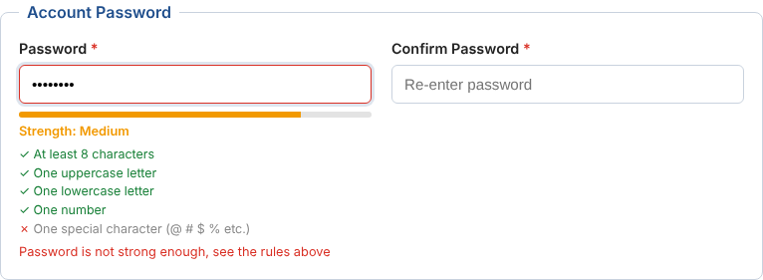
Figure 1: Strength meter for the password Arun2005 (no special character, so it shows Medium)
File upload: the File API gives the type and size of the selected file before anything is uploaded. The photo must be JPG or PNG and smaller than 2 MB, and a preview is shown with URL.createObjectURL(). The mark sheet is optional, but if a file is chosen it has to be a PDF smaller than 5 MB.
These checks run only in the browser, so they are mainly for the convenience of the user. Anyone can switch off JavaScript and send any data, so the same checks are done again on the server in the PHP admin panel (Question 2).
Table 3: Validation rules of the registration form
Field | Validation rule | Message shown
Full Name | Required. Only letters, dot and space, 3 to 50 characters | Only letters, dot and space allowed (3 to 50 characters)
Roll Number | Required. 2 digit year + 2 to 4 letters + 3 digits (e.g. 23CS101). Converted to upper case | Invalid format. Example: 23CS101
Email ID | Required. Must match name@domain.ext | Enter a valid email (eg. name@gmail.com)
Mobile Number | Required. 10 digits starting with 6, 7, 8 or 9 | Enter a valid 10 digit mobile number
Course | An option must be selected | Please select a course
Gender | One radio button must be selected | Please select gender
Password | Required. All five strength rules must pass | Password is not strong enough, see the rules above
Confirm Password | Must be the same as Password | Passwords do not match
Photo | Required. JPG or PNG only, maximum 2 MB | Only JPG or PNG images are allowed / Photo size should be less than 2 MB
12th Mark Sheet | Optional. If chosen, PDF only, maximum 5 MB | Mark sheet must be a PDF file / PDF size should be less than 5 MB
Declaration | Checkbox must be ticked | You must accept the declaration

5.5 Output Screenshots
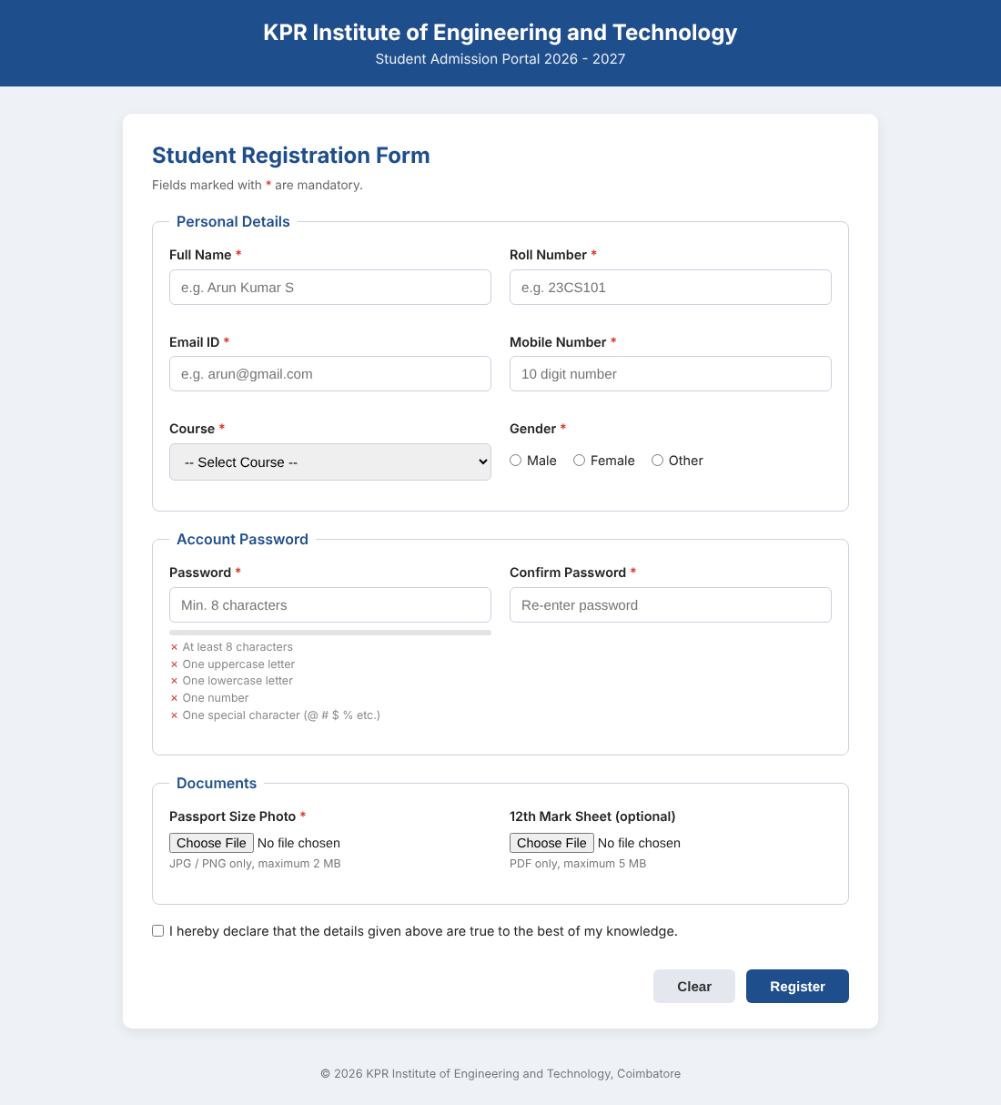
Figure 2: Registration form when the page is opened
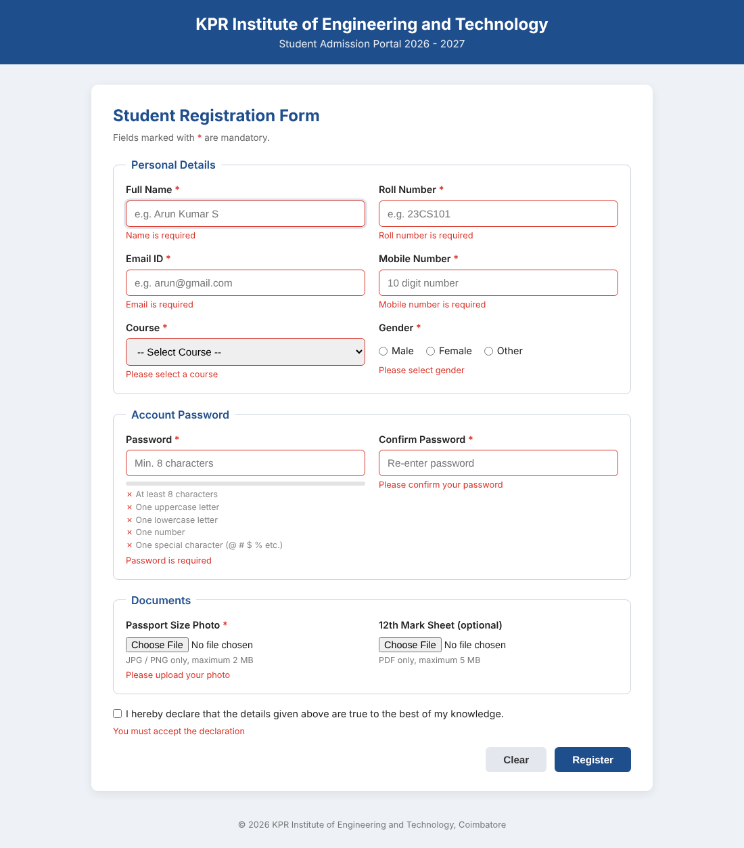
Figure 3: Messages shown when Register is clicked with an empty form
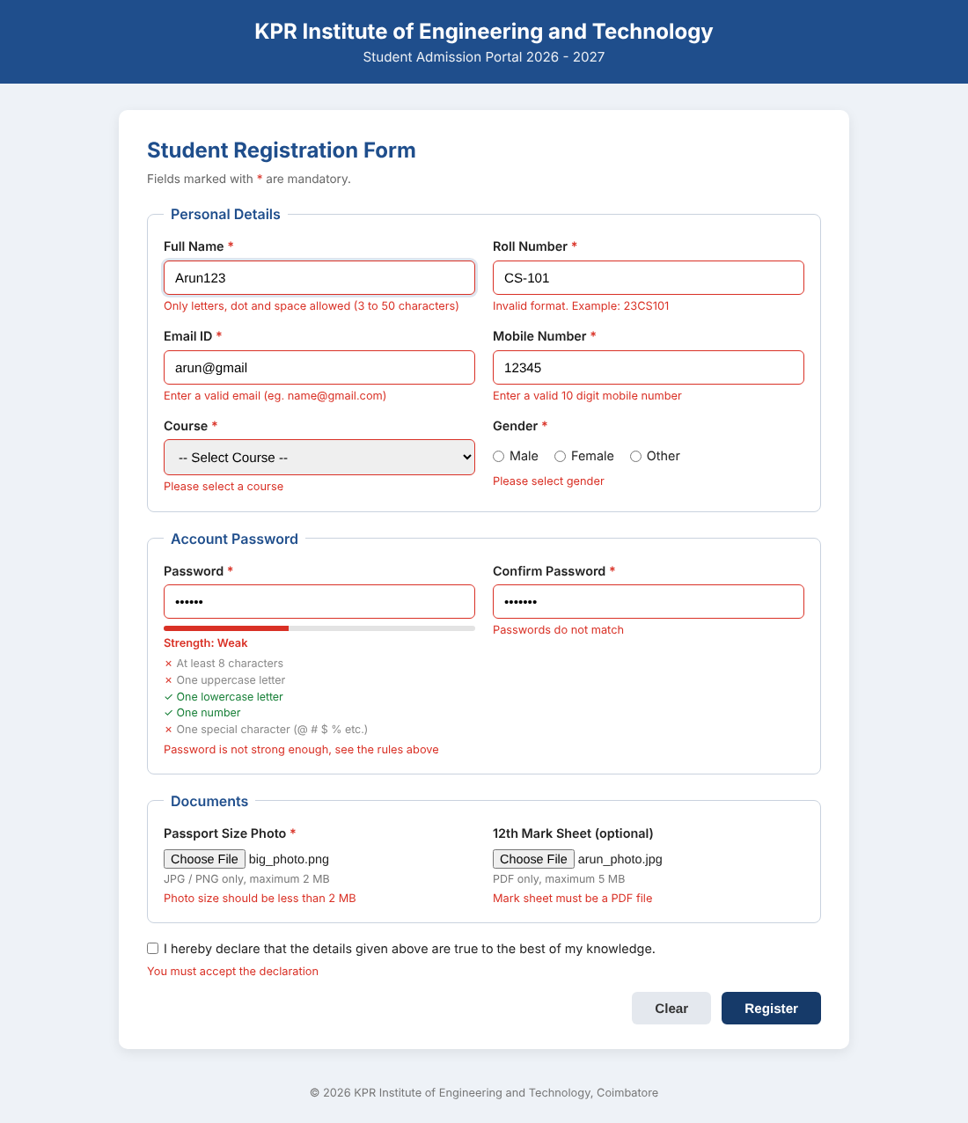
Figure 4: Wrong inputs: invalid name, roll number, email and mobile, weak password, confirm password not matching, a 6 MB photo and a JPG chosen as the mark sheet
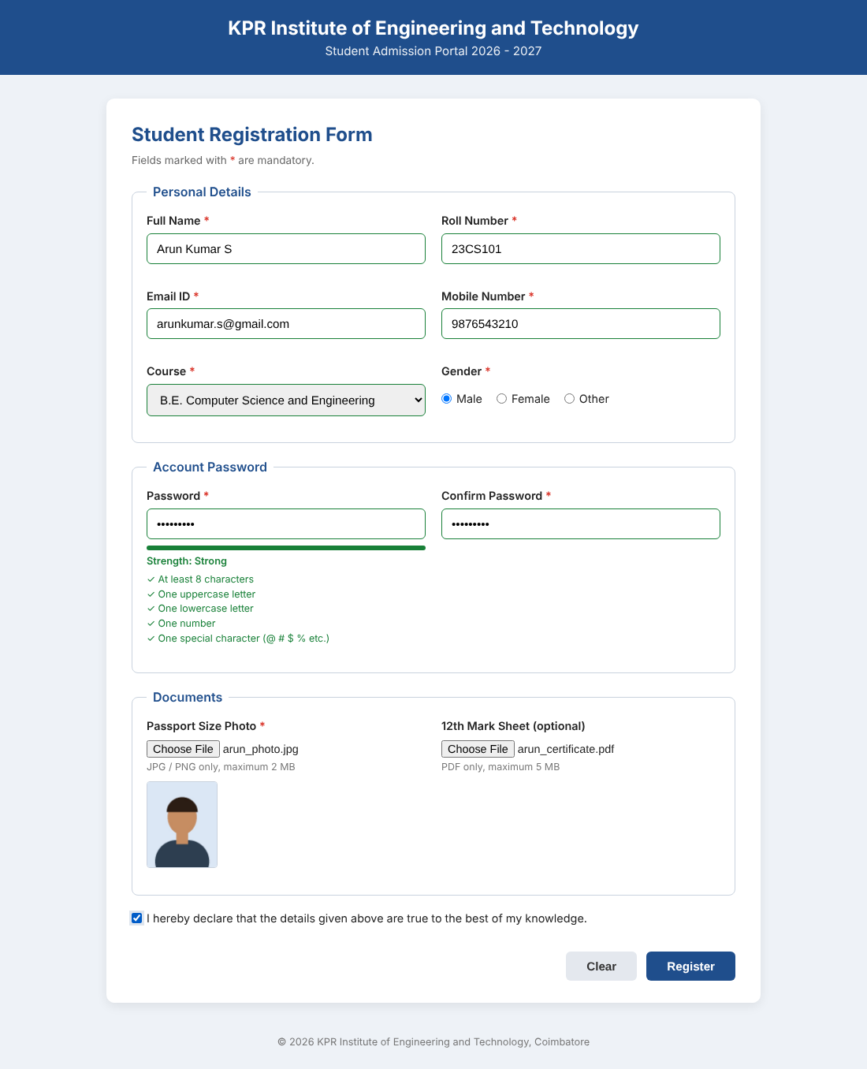
Figure 5: All fields valid (green borders), strong password and photo preview
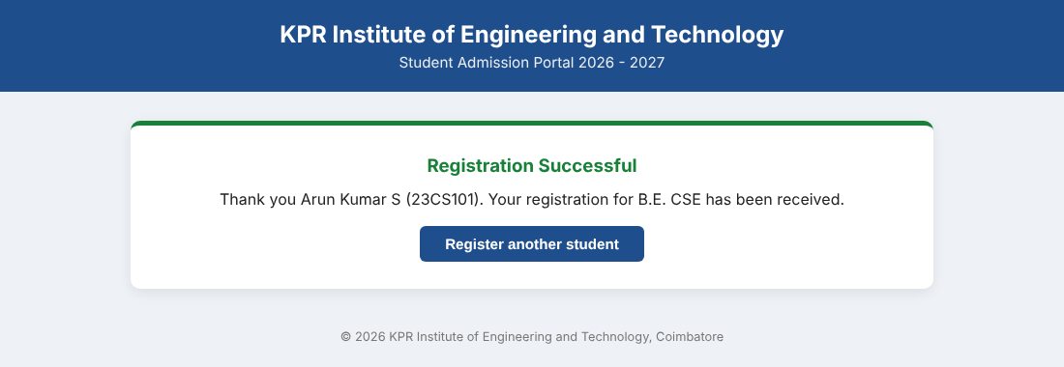
Figure 6: Success message after submitting valid data
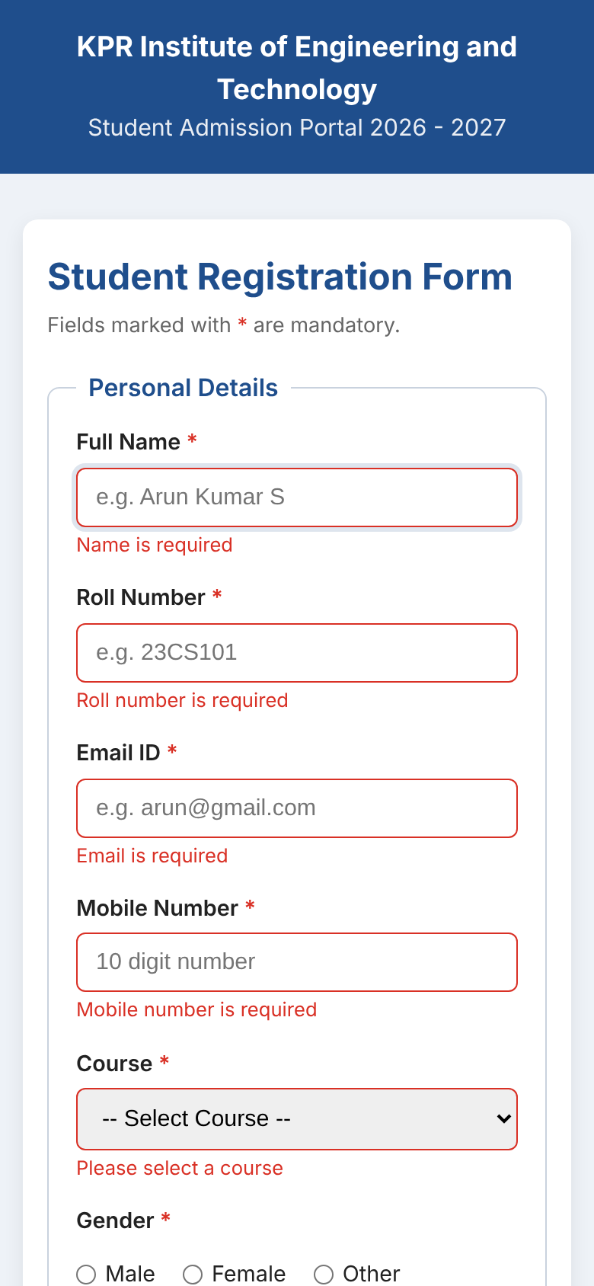
Figure 7: Same form on a mobile screen (390 px wide), fields stacked in one column

6. Question 2 - Admin Panel using PHP and MySQL

6.1 Requirement
Create PHP pages for the college admin panel that perform CRUD operations (add, edit, delete, view) on student details using MySQL, handle the upload of profile images and documents such as ID proof and certificates, store the file metadata (file path, file type, upload date) in MySQL linked to the student record, display the uploaded files when a student is viewed, and validate the files (size, type) without overwriting existing files.

6.2 Pages in the Admin Panel
Table 4: Files of the PHP admin panel
File | What it does
db.php | Database connection and common settings (upload folder, size limits, list of courses). Starts the session used for messages.
functions.php | Helper functions: output escaping, flash messages, server side validation, saveUploadedFile(), insertFileRecord(), removeFiles()
header.php, footer.php | Common top bar and footer included in every page
index.php | View (all): lists students with photo thumbnail, number of documents and a search box
add.php | Create: form to add a student with profile photo, ID proof and certificate
view.php | View (one): details of one student with the photo and a table of uploaded documents
edit.php | Update: change details, replace the photo, add more documents and delete single files
delete.php | Delete: removes the student, the file rows and the files on disk
delete_file.php | Removes one uploaded file (database row and physical file)
css/admin.css | Styling of the admin panel

6.3 Source Code
File: q2_admin_php/db.php
<?php
// db.php - database connection and common settings.
// Every page includes this file first.

// change these according to your XAMPP / WAMP setup
define('DB_HOST', 'localhost');
define('DB_USER', 'root');
define('DB_PASS', '');
define('DB_NAME', 'college_db');

// uploaded files are kept inside this folder (profile/ and documents/ sub folders)
define('UPLOAD_DIR', __DIR__ . '/uploads/');
define('UPLOAD_URL', 'uploads/');

// size limits in bytes
define('MAX_IMAGE_SIZE', 2 * 1024 * 1024); // 2 MB for profile photo
define('MAX_DOC_SIZE', 5 * 1024 * 1024); // 5 MB for ID proof / certificates

// list of courses shown in the drop down (also used for server side validation)
define('COURSES', ['B.E. CSE', 'B.Tech IT', 'B.Tech AI&DS', 'B.E. ECE', 'B.E. EEE', 'B.E. MECH']);

// make mysqli throw exceptions instead of silently returning false
mysqli_report(MYSQLI_REPORT_ERROR | MYSQLI_REPORT_STRICT);

// Indian time for date() and for MySQL timestamps
date_default_timezone_set('Asia/Kolkata');

try {
$conn = new mysqli(DB_HOST, DB_USER, DB_PASS, DB_NAME);
$conn->set_charset('utf8mb4');
$conn->query("SET time_zone = '+05:30'");
} catch (mysqli_sql_exception $e) {
// the real error goes to the log file, the user only sees a simple message
error_log('DB connection failed: ' . $e->getMessage());
die('<h3 style="color:#c00;font-family:Arial">Unable to connect to the database. Check the settings in db.php</h3>');
}

// session is used only to carry success / error messages between pages
if (session_status() === PHP_SESSION_NONE) {
session_start();
}

File: q2_admin_php/functions.php
<?php
// functions.php - helper functions used by the admin pages

// escape any value before printing it in HTML (prevents XSS)
function e($value) {
return htmlspecialchars((string)($value ?? ''), ENT_QUOTES, 'UTF-8');
}

// flash message = message stored in session and shown once on the next page
function setFlash($type, $message) {
$_SESSION['flash'] = ['type' => $type, 'msg' => $message];
}

function showFlash() {
if (!empty($_SESSION['flash'])) {
$f = $_SESSION['flash'];
echo '<div class="alert ' . e($f['type']) . '">' . e($f['msg']) . '</div>';
unset($_SESSION['flash']);
}
}

// converts bytes to KB / MB for display
function formatSize($bytes) {
if ($bytes >= 1048576) return round($bytes / 1048576, 2) . ' MB';
return round($bytes / 1024, 1) . ' KB';
}

// readable label for each file category
function categoryLabel($cat) {
$labels = ['PROFILE' => 'Profile Photo', 'ID_PROOF' => 'ID Proof', 'CERTIFICATE' => 'Certificate'];
return $labels[$cat] ?? $cat;
}

// checks the text fields of the student form and returns a list of error messages
function validateStudent($data) {
$errors = [];
if (!preg_match('/^[A-Za-z. ]{3,50}$/', $data['name'])) {
$errors[] = 'Name should contain only letters, dot and space (3 to 50 characters).';
}
if (!preg_match('/^[0-9]{2}[A-Z]{2,4}[0-9]{3}$/', $data['roll_no'])) {
$errors[] = 'Roll number format is wrong. Example: 23CS101';
}
if (!filter_var($data['email'], FILTER_VALIDATE_EMAIL)) {
$errors[] = 'Please enter a valid email address.';
}
if ($data['phone'] !== '' && !preg_match('/^[6-9][0-9]{9}$/', $data['phone'])) {
$errors[] = 'Phone number must be a valid 10 digit mobile number.';
}
if (!in_array($data['course'], COURSES, true)) {
$errors[] = 'Please select a course from the list.';
}
return $errors;
}

// allowed MIME types for each category (mime type => extension we save with)
function allowedTypes($category) {
if ($category === 'PROFILE') {
return ['image/jpeg' => 'jpg', 'image/png' => 'png'];
}
return ['application/pdf' => 'pdf', 'image/jpeg' => 'jpg', 'image/png' => 'png'];
}

/*
* Validates one uploaded file and moves it into the uploads folder.
* On success returns the details that have to be stored in MySQL.
* On any problem it throws an Exception with a message we can show to the user.
*/
function saveUploadedFile($file, $category, $rollNo) {
// 1. PHP's own upload error code
if ($file['error'] !== UPLOAD_ERR_OK) {
switch ($file['error']) {
case UPLOAD_ERR_INI_SIZE:
case UPLOAD_ERR_FORM_SIZE:
throw new Exception($file['name'] . ' is bigger than the size allowed by the server.');
case UPLOAD_ERR_PARTIAL:
throw new Exception($file['name'] . ' was only partly uploaded. Please try again.');
case UPLOAD_ERR_NO_FILE:
throw new Exception('No file was selected.');
default:
throw new Exception('Server error while uploading ' . $file['name'] . '.');
}
}

// 2. size check (different limit for photo and documents)
$maxSize = ($category === 'PROFILE') ? MAX_IMAGE_SIZE : MAX_DOC_SIZE;
if ($file['size'] > $maxSize) {
throw new Exception($file['name'] . ' is too large. Maximum allowed is ' . ($maxSize / 1048576) . ' MB.');
}
if ($file['size'] === 0) {
throw new Exception($file['name'] . ' is an empty file.');
}

// 3. type check - finfo reads the actual content of the file,
// so renaming virus.exe to photo.jpg will not fool it
$finfo = new finfo(FILEINFO_MIME_TYPE);
$mime = $finfo->file($file['tmp_name']);
$allowed = allowedTypes($category);
if (!isset($allowed[$mime])) {
$msg = ($category === 'PROFILE') ? 'only JPG or PNG images are allowed' : 'only PDF, JPG or PNG files are allowed';
throw new Exception($file['name'] . ' was rejected: ' . $msg . '.');
}

// 4. create a unique name so an existing file is never overwritten
$subFolder = ($category === 'PROFILE') ? 'profile/' : 'documents/';
$targetDir = UPLOAD_DIR . $subFolder;
if (!is_dir($targetDir)) {
mkdir($targetDir, 0755, true);
}

do {
$newName = strtolower($rollNo . '_' . $category) . '_' . date('Ymd_His') . '_'
. bin2hex(random_bytes(4)) . '.' . $allowed[$mime];
} while (file_exists($targetDir . $newName)); // extra safety, practically never loops

// 5. move from PHP temp folder to our uploads folder
if (!move_uploaded_file($file['tmp_name'], $targetDir . $newName)) {
throw new Exception('Could not save ' . $file['name'] . ' on the server.');
}

return [
'original_name' => basename($file['name']),
'stored_name' => $newName,
'file_path' => $subFolder . $newName, // relative path stored in DB
'file_type' => $mime,
'file_size' => $file['size'],
];
}

// stores the metadata of one uploaded file, linked to the student
function insertFileRecord($conn, $studentId, $category, $info) {
$sql = "INSERT INTO student_files
(student_id, file_category, original_name, stored_name, file_path, file_type, file_size)
VALUES (?, ?, ?, ?, ?, ?, ?)";
$stmt = $conn->prepare($sql);
$stmt->bind_param('isssssi', $studentId, $category, $info['original_name'],
$info['stored_name'], $info['file_path'], $info['file_type'], $info['file_size']);
$stmt->execute();
}

// removes files from disk (used for clean up when something fails)
function removeFiles($paths) {
foreach ($paths as $p) {
$full = UPLOAD_DIR . $p;
if (is_file($full)) {
unlink($full);
}
}
}

// fetches one student row, returns null if not found
function getStudent($conn, $id) {
$stmt = $conn->prepare('SELECT * FROM students WHERE id = ?');
$stmt->bind_param('i', $id);
$stmt->execute();
return $stmt->get_result()->fetch_assoc();
}

// all files of a student, profile photo first and then latest uploads
function getStudentFiles($conn, $id) {
$stmt = $conn->prepare("SELECT * FROM student_files WHERE student_id = ?
ORDER BY file_category = 'PROFILE' DESC, upload_date DESC");
$stmt->bind_param('i', $id);
$stmt->execute();
return $stmt->get_result()->fetch_all(MYSQLI_ASSOC);
}

// PHP drops $_POST and $_FILES completely if the request is bigger than post_max_size,
// so this check is needed to show a proper message in that case
function postTooLarge() {
return $_SERVER['REQUEST_METHOD'] === 'POST' && empty($_POST) && empty($_FILES)
&& (int)($_SERVER['CONTENT_LENGTH'] ?? 0) > 0;
}

File: q2_admin_php/header.php
<?php // header.php - common top part of every admin page. Set $pageTitle before including. ?>
<!DOCTYPE html>
<html lang="en">
<head>
<meta charset="UTF-8">
<meta name="viewport" content="width=device-width, initial-scale=1.0">
<title><?= e($pageTitle ?? 'Admin Panel') ?> | Student Admin Panel</title>
<link rel="stylesheet" href="css/admin.css">
</head>
<body>
<header class="topbar">
<div class="brand">Student Records <span>Admin Panel</span></div>
<nav>
<a href="index.php">All Students</a>
<a href="add.php" class="nav-btn">+ Add Student</a>
</nav>
</header>
<main class="wrap">

File: q2_admin_php/footer.php
</main>
<footer class="foot">Web Technology Assignment II - PHP &amp; MySQL Admin Panel</footer>
</body>
</html>

File: q2_admin_php/index.php
<?php
// index.php - lists all students (the "View" part of CRUD) with search
require 'db.php';
require 'functions.php';

$search = trim($_GET['q'] ?? '');

// LEFT JOIN with the profile photo so that we can show a thumbnail,
// and a sub query to count how many documents each student has
$sql = "SELECT s.id, s.name, s.roll_no, s.email, s.course,
p.file_path AS photo,
(SELECT COUNT(*) FROM student_files d
WHERE d.student_id = s.id AND d.file_category <> 'PROFILE') AS doc_count
FROM students s
LEFT JOIN student_files p ON p.student_id = s.id AND p.file_category = 'PROFILE'";

if ($search !== '') {
$sql .= " WHERE s.name LIKE ? OR s.roll_no LIKE ? OR s.course LIKE ?";
}
$sql .= " ORDER BY s.roll_no";

$stmt = $conn->prepare($sql);
if ($search !== '') {
$like = '%' . $search . '%';
$stmt->bind_param('sss', $like, $like, $like);
}
$stmt->execute();
$students = $stmt->get_result()->fetch_all(MYSQLI_ASSOC);

$pageTitle = 'All Students';
include 'header.php';
?>

<div class="page-head">
<h2>Student Records <small>(<?= count($students) ?> found)</small></h2>
<form method="get" class="search">
<input type="text" name="q" value="<?= e($search) ?>" placeholder="Search name, roll no or course">
<button type="submit" class="btn">Search</button>
<?php if ($search !== ''): ?><a href="index.php" class="btn btn-light">Clear</a><?php endif; ?>
</form>
</div>

<?php showFlash(); ?>

<?php if (empty($students)): ?>
<p class="empty">No student records found. <a href="add.php">Add the first student</a>.</p>
<?php else: ?>
<div class="table-box">
<table class="list">
<thead>
<tr>
<th>Photo</th><th>Roll No</th><th>Name</th><th>Course</th>
<th>Email</th><th>Documents</th><th>Actions</th>
</tr>
</thead>
<tbody>
<?php foreach ($students as $s): ?>
<tr>
<td>
<?php if ($s['photo']): ?>
<img src="<?= UPLOAD_URL . e($s['photo']) ?>" class="thumb" alt="photo">
<?php else: ?>
<span class="no-photo">No photo</span>
<?php endif; ?>
</td>
<td><?= e($s['roll_no']) ?></td>
<td><?= e($s['name']) ?></td>
<td><?= e($s['course']) ?></td>
<td><?= e($s['email']) ?></td>
<td><?= (int)$s['doc_count'] ?></td>
<td class="actions">
<a href="view.php?id=<?= $s['id'] ?>" class="btn btn-sm">View</a>
<a href="edit.php?id=<?= $s['id'] ?>" class="btn btn-sm btn-warn">Edit</a>
<!-- delete is done with POST, a plain link could be triggered by mistake -->
<form action="delete.php" method="post" class="inline"
onsubmit="return confirm('Delete <?= e($s['name']) ?> and all uploaded files?');">
<input type="hidden" name="id" value="<?= $s['id'] ?>">
<button type="submit" class="btn btn-sm btn-danger">Delete</button>
</form>
</td>
</tr>
<?php endforeach; ?>
</tbody>
</table>
</div>
<?php endif; ?>

<?php include 'footer.php'; ?>

File: q2_admin_php/add.php
<?php
// add.php - "Create" part of CRUD. Adds a student along with photo / documents.
require 'db.php';
require 'functions.php';

$errors = [];
$old = ['name' => '', 'roll_no' => '', 'email' => '', 'phone' => '', 'course' => ''];

if (postTooLarge()) {
$errors[] = 'The files you selected are too large for the server. Please choose smaller files.';
} elseif ($_SERVER['REQUEST_METHOD'] === 'POST') {

// read and clean the form values (kept in $old so the form is refilled on error)
$old = [
'name' => trim($_POST['name'] ?? ''),
'roll_no' => strtoupper(trim($_POST['roll_no'] ?? '')),
'email' => strtolower(trim($_POST['email'] ?? '')),
'phone' => trim($_POST['phone'] ?? ''),
'course' => $_POST['course'] ?? '',
];

$errors = validateStudent($old);
if (empty($_FILES['profile']['name'])) {
$errors[] = 'Profile photo is required.';
}

if (empty($errors)) {
$savedFiles = []; // remember saved files so we can delete them if DB insert fails
$conn->begin_transaction(); // student row + file rows are saved together or not at all
try {
$stmt = $conn->prepare('INSERT INTO students (name, roll_no, email, phone, course) VALUES (?, ?, ?, ?, ?)');
$stmt->bind_param('sssss', $old['name'], $old['roll_no'], $old['email'], $old['phone'], $old['course']);
$stmt->execute();
$studentId = $conn->insert_id;

// form field name => category stored in the database
$uploadFields = ['profile' => 'PROFILE', 'id_proof' => 'ID_PROOF', 'certificate' => 'CERTIFICATE'];

foreach ($uploadFields as $field => $category) {
if (!empty($_FILES[$field]['name'])) { // ID proof and certificate are optional
$info = saveUploadedFile($_FILES[$field], $category, $old['roll_no']);
$savedFiles[] = $info['file_path'];
insertFileRecord($conn, $studentId, $category, $info);
}
}

$conn->commit();
setFlash('success', 'Student ' . $old['name'] . ' (' . $old['roll_no'] . ') was added successfully.');
header('Location: index.php');
exit;

} catch (mysqli_sql_exception $ex) {
$conn->rollback();
removeFiles($savedFiles);
// 1062 = duplicate entry (roll_no and email are UNIQUE in the table)
$errors[] = ($ex->getCode() == 1062)
? 'A student with this roll number or email already exists.'
: 'Database error, the record was not saved.';
error_log($ex->getMessage());
} catch (Exception $ex) {
// file validation errors thrown by saveUploadedFile()
$conn->rollback();
removeFiles($savedFiles);
$errors[] = $ex->getMessage();
}
}
}

$pageTitle = 'Add Student';
include 'header.php';
?>

<div class="card">
<h2>Add New Student</h2>

<?php if ($errors): ?>
<div class="alert error">
<strong>Please correct the following:</strong>
<ul><?php foreach ($errors as $err): ?><li><?= e($err) ?></li><?php endforeach; ?></ul>
</div>
<?php endif; ?>

<!-- enctype multipart/form-data is a must, otherwise files are not sent -->
<form method="post" enctype="multipart/form-data" class="form-grid">
<label>Full Name *
<input type="text" name="name" value="<?= e($old['name']) ?>" required>
</label>
<label>Roll Number *
<input type="text" name="roll_no" value="<?= e($old['roll_no']) ?>" placeholder="23CS101" required>
</label>
<label>Email *
<input type="email" name="email" value="<?= e($old['email']) ?>" required>
</label>
<label>Phone
<input type="text" name="phone" value="<?= e($old['phone']) ?>" maxlength="10">
</label>
<label>Course *
<select name="course" required>
<option value="">-- Select --</option>
<?php foreach (COURSES as $c): ?>
<option value="<?= e($c) ?>" <?= $old['course'] === $c ? 'selected' : '' ?>><?= e($c) ?></option>
<?php endforeach; ?>
</select>
</label>
<span></span>

<label>Profile Photo * <small>(JPG/PNG, max 2 MB)</small>
<input type="file" name="profile" accept="image/jpeg,image/png">
</label>
<label>ID Proof <small>(PDF/JPG/PNG, max 5 MB)</small>
<input type="file" name="id_proof" accept=".pdf,image/jpeg,image/png">
</label>
<label>Certificate <small>(PDF/JPG/PNG, max 5 MB)</small>
<input type="file" name="certificate" accept=".pdf,image/jpeg,image/png">
</label>

<div class="form-actions">
<a href="index.php" class="btn btn-light">Cancel</a>
<button type="submit" class="btn">Save Student</button>
</div>
</form>
</div>

<?php include 'footer.php'; ?>

File: q2_admin_php/view.php
<?php
// view.php - shows one student with the profile photo and all uploaded documents
require 'db.php';
require 'functions.php';

$id = filter_input(INPUT_GET, 'id', FILTER_VALIDATE_INT);
$student = $id ? getStudent($conn, $id) : null;

if (!$student) {
setFlash('error', 'Student not found.');
header('Location: index.php');
exit;
}

$files = getStudentFiles($conn, $id);

// separate the profile photo from the other documents
$photo = null;
$documents = [];
foreach ($files as $f) {
if ($f['file_category'] === 'PROFILE' && $photo === null) {
$photo = $f;
} else {
$documents[] = $f;
}
}

$pageTitle = $student['name'];
include 'header.php';
?>

<?php showFlash(); ?>

<div class="card profile">
<div class="profile-photo">
<?php if ($photo): ?>
<img src="<?= UPLOAD_URL . e($photo['file_path']) ?>" alt="Profile photo of <?= e($student['name']) ?>">
<?php else: ?>
<div class="no-photo big">No Photo</div>
<?php endif; ?>
</div>

<div class="profile-info">
<h2><?= e($student['name']) ?></h2>
<table class="details">
<tr><th>Roll Number</th><td><?= e($student['roll_no']) ?></td></tr>
<tr><th>Course</th><td><?= e($student['course']) ?></td></tr>
<tr><th>Email</th><td><?= e($student['email']) ?></td></tr>
<tr><th>Phone</th><td><?= e($student['phone'] ?: '-') ?></td></tr>
<tr><th>Added On</th><td><?= date('d M Y, h:i A', strtotime($student['created_at'])) ?></td></tr>
</table>
<div class="form-actions left">
<a href="edit.php?id=<?= $id ?>" class="btn btn-warn">Edit Details</a>
<a href="index.php" class="btn btn-light">Back to List</a>
</div>
</div>
</div>

<div class="card">
<h3>Uploaded Documents</h3>
<?php if (empty($documents)): ?>
<p class="empty">No documents uploaded for this student.</p>
<?php else: ?>
<table class="list">
<thead>
<tr><th>Type</th><th>File Name</th><th>Format</th><th>Size</th><th>Uploaded On</th><th>Preview / Open</th></tr>
</thead>
<tbody>
<?php foreach ($documents as $d): ?>
<tr>
<td><?= categoryLabel($d['file_category']) ?></td>
<td><?= e($d['original_name']) ?></td>
<td><?= e($d['file_type']) ?></td>
<td><?= formatSize($d['file_size']) ?></td>
<td><?= date('d-m-Y h:i A', strtotime($d['upload_date'])) ?></td>
<td>
<?php if (str_starts_with($d['file_type'], 'image/')): ?>
<!-- images are shown directly -->
<a href="<?= UPLOAD_URL . e($d['file_path']) ?>" target="_blank">
<img src="<?= UPLOAD_URL . e($d['file_path']) ?>" class="doc-thumb" alt="document">
</a>
<?php else: ?>
<!-- PDFs open in a new tab -->
<a href="<?= UPLOAD_URL . e($d['file_path']) ?>" target="_blank" class="btn btn-sm">Open PDF</a>
<?php endif; ?>
</td>
</tr>
<?php endforeach; ?>
</tbody>
</table>
<?php endif; ?>
</div>

<?php include 'footer.php'; ?>

File: q2_admin_php/edit.php
<?php
// edit.php - "Update" part of CRUD.
// Details can be changed, the profile photo can be replaced and new documents can be added.
require 'db.php';
require 'functions.php';

$id = filter_input(INPUT_GET, 'id', FILTER_VALIDATE_INT);
$student = $id ? getStudent($conn, $id) : null;
if (!$student) {
setFlash('error', 'Student not found.');
header('Location: index.php');
exit;
}

$errors = [];
$old = $student; // form is filled with the current values

if (postTooLarge()) {
$errors[] = 'The files you selected are too large for the server. Please choose smaller files.';
} elseif ($_SERVER['REQUEST_METHOD'] === 'POST') {
$old = [
'name' => trim($_POST['name'] ?? ''),
'roll_no' => strtoupper(trim($_POST['roll_no'] ?? '')),
'email' => strtolower(trim($_POST['email'] ?? '')),
'phone' => trim($_POST['phone'] ?? ''),
'course' => $_POST['course'] ?? '',
];
$errors = validateStudent($old);

$docCategory = $_POST['doc_category'] ?? '';
if (!empty($_FILES['new_doc']['name']) && !in_array($docCategory, ['ID_PROOF', 'CERTIFICATE'], true)) {
$errors[] = 'Select whether the new document is an ID proof or a certificate.';
}

if (empty($errors)) {
$savedFiles = [];
$oldPhotoToDelete = null;
$conn->begin_transaction();
try {
$stmt = $conn->prepare('UPDATE students SET name = ?, roll_no = ?, email = ?, phone = ?, course = ? WHERE id = ?');
$stmt->bind_param('sssssi', $old['name'], $old['roll_no'], $old['email'], $old['phone'], $old['course'], $id);
$stmt->execute();

// new profile photo -> save new one first, then remove the old record
if (!empty($_FILES['profile']['name'])) {
$info = saveUploadedFile($_FILES['profile'], 'PROFILE', $old['roll_no']);
$savedFiles[] = $info['file_path'];

$q = $conn->prepare("SELECT file_id, file_path FROM student_files WHERE student_id = ? AND file_category = 'PROFILE'");
$q->bind_param('i', $id);
$q->execute();
$oldPhotoToDelete = $q->get_result()->fetch_assoc();

if ($oldPhotoToDelete) {
$del = $conn->prepare('DELETE FROM student_files WHERE file_id = ?');
$del->bind_param('i', $oldPhotoToDelete['file_id']);
$del->execute();
}
insertFileRecord($conn, $id, 'PROFILE', $info);
}

// optional extra document
if (!empty($_FILES['new_doc']['name'])) {
$info = saveUploadedFile($_FILES['new_doc'], $docCategory, $old['roll_no']);
$savedFiles[] = $info['file_path'];
insertFileRecord($conn, $id, $docCategory, $info);
}

$conn->commit();

// old photo file is deleted from disk only after the DB changes are committed
if ($oldPhotoToDelete) {
removeFiles([$oldPhotoToDelete['file_path']]);
}

setFlash('success', 'Details of ' . $old['name'] . ' updated successfully.');
header('Location: view.php?id=' . $id);
exit;

} catch (mysqli_sql_exception $ex) {
$conn->rollback();
removeFiles($savedFiles);
$errors[] = ($ex->getCode() == 1062)
? 'Another student already has this roll number or email.'
: 'Database error, changes were not saved.';
error_log($ex->getMessage());
} catch (Exception $ex) {
$conn->rollback();
removeFiles($savedFiles);
$errors[] = $ex->getMessage();
}
}
}

$files = getStudentFiles($conn, $id);

$pageTitle = 'Edit Student';
include 'header.php';
?>

<div class="card">
<h2>Edit Student - <?= e($student['roll_no']) ?></h2>

<?php if ($errors): ?>
<div class="alert error">
<strong>Please correct the following:</strong>
<ul><?php foreach ($errors as $err): ?><li><?= e($err) ?></li><?php endforeach; ?></ul>
</div>
<?php endif; ?>

<form method="post" enctype="multipart/form-data" class="form-grid">
<label>Full Name *
<input type="text" name="name" value="<?= e($old['name']) ?>" required>
</label>
<label>Roll Number *
<input type="text" name="roll_no" value="<?= e($old['roll_no']) ?>" required>
</label>
<label>Email *
<input type="email" name="email" value="<?= e($old['email']) ?>" required>
</label>
<label>Phone
<input type="text" name="phone" value="<?= e($old['phone']) ?>" maxlength="10">
</label>
<label>Course *
<select name="course" required>
<?php foreach (COURSES as $c): ?>
<option value="<?= e($c) ?>" <?= $old['course'] === $c ? 'selected' : '' ?>><?= e($c) ?></option>
<?php endforeach; ?>
</select>
</label>
<label>Replace Profile Photo <small>(leave empty to keep current)</small>
<input type="file" name="profile" accept="image/jpeg,image/png">
</label>
<label>Add Document
<input type="file" name="new_doc" accept=".pdf,image/jpeg,image/png">
</label>
<label>Document Type
<select name="doc_category">
<option value="">-- Select --</option>
<option value="ID_PROOF">ID Proof</option>
<option value="CERTIFICATE">Certificate</option>
</select>
</label>

<div class="form-actions">
<a href="view.php?id=<?= $id ?>" class="btn btn-light">Cancel</a>
<button type="submit" class="btn">Update Student</button>
</div>
</form>
</div>

<div class="card">
<h3>Existing Files</h3>
<?php if (empty($files)): ?>
<p class="empty">No files uploaded yet.</p>
<?php else: ?>
<table class="list">
<thead><tr><th>Type</th><th>File Name</th><th>Size</th><th>Uploaded On</th><th>Action</th></tr></thead>
<tbody>
<?php foreach ($files as $f): ?>
<tr>
<td><?= categoryLabel($f['file_category']) ?></td>
<td><a href="<?= UPLOAD_URL . e($f['file_path']) ?>" target="_blank"><?= e($f['original_name']) ?></a></td>
<td><?= formatSize($f['file_size']) ?></td>
<td><?= date('d-m-Y h:i A', strtotime($f['upload_date'])) ?></td>
<td>
<form action="delete_file.php" method="post" class="inline"
onsubmit="return confirm('Delete this file permanently?');">
<input type="hidden" name="file_id" value="<?= $f['file_id'] ?>">
<input type="hidden" name="student_id" value="<?= $id ?>">
<button type="submit" class="btn btn-sm btn-danger">Delete</button>
</form>
</td>
</tr>
<?php endforeach; ?>
</tbody>
</table>
<?php endif; ?>
</div>

<?php include 'footer.php'; ?>

File: q2_admin_php/delete.php
<?php
// delete.php - "Delete" part of CRUD. Removes the student row and all his files.
require 'db.php';
require 'functions.php';

// only POST is accepted so that a student is never deleted just by opening a link
if ($_SERVER['REQUEST_METHOD'] !== 'POST') {
header('Location: index.php');
exit;
}

$id = filter_input(INPUT_POST, 'id', FILTER_VALIDATE_INT);
$student = $id ? getStudent($conn, $id) : null;

if (!$student) {
setFlash('error', 'Student not found, nothing was deleted.');
header('Location: index.php');
exit;
}

try {
// collect file paths before the rows disappear
$paths = array_column(getStudentFiles($conn, $id), 'file_path');

// ON DELETE CASCADE in the table removes the student_files rows automatically
$stmt = $conn->prepare('DELETE FROM students WHERE id = ?');
$stmt->bind_param('i', $id);
$stmt->execute();

// now delete the actual files from the uploads folder
removeFiles($paths);

setFlash('success', 'Student ' . $student['name'] . ' and ' . count($paths) . ' file(s) deleted.');
} catch (mysqli_sql_exception $ex) {
error_log($ex->getMessage());
setFlash('error', 'Could not delete the student. Please try again.');
}

header('Location: index.php');
exit;

File: q2_admin_php/delete_file.php
<?php
// delete_file.php - removes a single uploaded file (row + physical file)
require 'db.php';
require 'functions.php';

if ($_SERVER['REQUEST_METHOD'] !== 'POST') {
header('Location: index.php');
exit;
}

$fileId = filter_input(INPUT_POST, 'file_id', FILTER_VALIDATE_INT);
$studentId = filter_input(INPUT_POST, 'student_id', FILTER_VALIDATE_INT);

// student_id is also checked so that a file of another student cannot be deleted by changing the id
$stmt = $conn->prepare('SELECT file_path, original_name FROM student_files WHERE file_id = ? AND student_id = ?');
$stmt->bind_param('ii', $fileId, $studentId);
$stmt->execute();
$file = $stmt->get_result()->fetch_assoc();

if ($file) {
$del = $conn->prepare('DELETE FROM student_files WHERE file_id = ?');
$del->bind_param('i', $fileId);
$del->execute();
removeFiles([$file['file_path']]);
setFlash('success', $file['original_name'] . ' was deleted.');
} else {
setFlash('error', 'File not found.');
}

header('Location: view.php?id=' . (int)$studentId);
exit;

File: q2_admin_php/css/admin.css
/* admin.css - styles for the PHP admin panel */
* { box-sizing: border-box; margin: 0; padding: 0; }

body {
font-family: "Segoe UI", Arial, sans-serif;
background: #f1f4f8;
color: #222;
font-size: 15px;
}

/* top navigation bar */
.topbar {
background: #1f4e8c;
color: #fff;
display: flex;
justify-content: space-between;
align-items: center;
padding: 14px 30px;
}
.brand { font-size: 1.25rem; font-weight: 700; }
.brand span { font-weight: 400; opacity: 0.8; font-size: 0.95rem; }
.topbar nav a { color: #fff; text-decoration: none; margin-left: 18px; }
.topbar .nav-btn { background: #fff; color: #1f4e8c; padding: 7px 14px; border-radius: 5px; font-weight: 600; }

.wrap { max-width: 1100px; margin: 25px auto; padding: 0 15px; }

.page-head { display: flex; justify-content: space-between; align-items: center; margin-bottom: 15px; flex-wrap: wrap; gap: 10px; }
.page-head small { color: #777; font-weight: normal; font-size: 0.9rem; }
.search { display: flex; gap: 6px; }
.search input { padding: 8px 10px; border: 1px solid #c5ced9; border-radius: 5px; width: 260px; }

.card {
background: #fff;
padding: 22px 26px;
border-radius: 8px;
box-shadow: 0 2px 10px rgba(0, 0, 0, 0.06);
margin-bottom: 20px;
}
.card h2, .card h3 { color: #1f4e8c; margin-bottom: 14px; }

/* buttons */
.btn {
display: inline-block;
background: #1f4e8c;
color: #fff;
border: none;
padding: 8px 16px;
border-radius: 5px;
text-decoration: none;
cursor: pointer;
font-size: 0.9rem;
}
.btn:hover { opacity: 0.9; }
.btn-light { background: #e2e7ee; color: #333; }
.btn-warn { background: #e8a317; }
.btn-danger { background: #c62828; }
.btn-sm { padding: 5px 10px; font-size: 0.8rem; }
form.inline { display: inline; }

/* tables */
.table-box { background: #fff; border-radius: 8px; box-shadow: 0 2px 10px rgba(0, 0, 0, 0.06); overflow-x: auto; }
table.list { width: 100%; border-collapse: collapse; }
table.list th { background: #e9eef5; text-align: left; padding: 10px 12px; font-size: 0.85rem; color: #333; }
table.list td { padding: 9px 12px; border-top: 1px solid #edf0f4; vertical-align: middle; font-size: 0.9rem; }
table.list tr:hover td { background: #fafbfd; }
.actions { white-space: nowrap; }

.thumb { width: 46px; height: 54px; object-fit: cover; border-radius: 4px; border: 1px solid #ddd; }
.doc-thumb { width: 96px; height: 60px; object-fit: cover; border-radius: 4px; border: 1px solid #ddd; }
.no-photo { font-size: 0.75rem; color: #999; }
.no-photo.big {
width: 160px; height: 190px; display: flex; align-items: center; justify-content: center;
background: #eceff3; border-radius: 6px; font-size: 1rem;
}

/* forms */
.form-grid { display: grid; grid-template-columns: 1fr 1fr; gap: 14px 24px; }
.form-grid label { display: flex; flex-direction: column; font-weight: 600; font-size: 0.88rem; gap: 5px; }
.form-grid small { font-weight: normal; color: #777; }
.form-grid input[type="text"], .form-grid input[type="email"], .form-grid select {
padding: 9px 10px; border: 1px solid #c5ced9; border-radius: 5px; font-size: 0.95rem;
}
.form-actions { grid-column: 1 / -1; display: flex; justify-content: flex-end; gap: 10px; margin-top: 6px; }
.form-actions.left { justify-content: flex-start; }

/* messages */
.alert { padding: 12px 16px; border-radius: 6px; margin-bottom: 16px; font-size: 0.9rem; }
.alert.success { background: #e6f4ea; color: #1e6b34; border-left: 5px solid #34a853; }
.alert.error { background: #fdecea; color: #a52714; border-left: 5px solid #d93025; }
.alert ul { margin: 6px 0 0 20px; }
.empty { color: #777; padding: 10px 0; }

/* profile view */
.profile { display: flex; gap: 30px; align-items: flex-start; }
.profile-photo img { width: 160px; height: 190px; object-fit: cover; border-radius: 6px; border: 1px solid #ddd; }
.profile-info { flex: 1; }
table.details th { text-align: left; padding: 6px 20px 6px 0; color: #555; width: 140px; }
table.details td { padding: 6px 0; }

.foot { text-align: center; color: #888; font-size: 0.8rem; padding: 20px 0; }

@media (max-width: 700px) {
.form-grid { grid-template-columns: 1fr; }
.profile { flex-direction: column; }
.topbar { flex-direction: column; gap: 8px; }
}

An .htaccess file with the single line Options -Indexes is also placed inside the uploads folder so that nobody can open the folder in the browser and see the list of all uploaded files.

6.4 Explanation

(1) CRUD operations
All four operations use mysqli prepared statements (prepare, bind_param, execute). Values typed in the form are never joined directly into the SQL string, so SQL injection is not possible. add.php does the INSERT, edit.php the UPDATE and delete.php the DELETE. index.php lists the students using a LEFT JOIN with the profile photo and a sub query that counts the documents. LEFT JOIN is used so that a student without a photo still appears in the list (23EC121 in Figure 16).
Delete is done through a small form with method POST and a JavaScript confirm box. I did not use a normal link for delete, because a link can be opened by mistake (or even pre-loaded by the browser) and the record would be gone.

(2) File upload handling
The form uses enctype="multipart/form-data"; without it PHP does not receive the files at all. Every uploaded file goes through saveUploadedFile() in functions.php, which does these steps in order:
- Checks the error code given by PHP (file bigger than the php.ini limit, partial upload, no file).
- Checks the size: 2 MB for the profile photo and 5 MB for documents. Empty files are also rejected.
- Finds the real type of the file using finfo. finfo reads the first bytes of the file, so a text file renamed as photo.jpg is caught (Figure 9). The type sent by the browser ($_FILES['x']['type']) is not trusted because it can be changed by the user.
- Makes a new unique name: roll number + category + date and time + 8 random hex characters, for example 23cs101_profile_20261007_150247_2c729c1a.jpg. The extension is decided by the server from the MIME type, not taken from the user's file name.
- Moves the file from PHP's temporary folder to uploads/profile/ or uploads/documents/ using move_uploaded_file().

(3) Storing metadata in MySQL
After a file is moved, insertFileRecord() inserts a row in student_files with the student id, category, original file name, stored name, relative path, MIME type, size in bytes and upload date. Only the relative path (for example profile/23cs101_profile_....jpg) is stored, so if the project is moved to another folder or system nothing in the database needs to change.
In add.php the student row and the file rows are saved inside one transaction (begin_transaction, commit and rollback). If any file fails, the student row is rolled back and the files that were already saved are deleted by removeFiles(). So there is never a student without his files or a file without a student.

(4) Displaying uploaded files
view.php reads all files of the student and separates the profile photo from the other documents. Image documents are shown as small previews and PDF documents get an Open PDF button which opens the file in a new tab. The size is shown in KB or MB using formatSize() and the upload date is formatted with date(). The list page also shows a thumbnail of each student's photo.

(5) Validation and error handling
- Text fields are validated again on the server in validateStudent(): name pattern, roll number pattern, filter_var() for email, phone pattern, and the course must be one from the list.
- Overwriting is prevented in two ways: the unique file name described above, and a do-while loop that checks file_exists() before the name is used.
- Duplicate roll number or email: these columns are UNIQUE, so MySQL returns error 1062. The code catches it and shows a readable message (Figure 12). No uploaded file is left behind because of the rollback.
- If the total upload is bigger than post_max_size, PHP silently empties $_POST and $_FILES. postTooLarge() detects this and shows a message instead of a blank page.
- When the profile photo is replaced, the new file is saved first and the old file is deleted from disk only after the commit, so a failed update never loses the old photo.
- All output is printed through e(), a short wrapper for htmlspecialchars(), to prevent XSS. Database errors are written to the log with error_log() and the user only sees a simple message.
- delete_file.php checks both file_id and student_id, so a file of another student cannot be deleted by changing the id in the request.

6.5 Metadata Stored in MySQL
The rows below were taken from the student_files table (SELECT * FROM student_files) after the test run shown in the screenshots. file_id 11 is missing because that file, the photo of 23EC121, was deleted while testing delete_file.php. The student ids start from 3 because ids 1 and 2 were used by the two rejected attempts in Figures 9 and 10; MySQL does not reuse an AUTO_INCREMENT value after a rollback.
Table 5: Contents of the student_files table
file  id | student  id | category | original name | file_path | file_type | size  (bytes) | upload_date
1 | 3 | PROFILE | arun_photo.jpg | profile/23cs101_profile_20261007_150247_2c729c1a.jpg | image/jpeg | 9426 | 07-10-2026 15:02:47
2 | 3 | ID_PROOF | arun_id_card.jpg | documents/23cs101_id_proof_20261007_150247_2c168a59.jpg | image/jpeg | 47311 | 07-10-2026 15:02:47
3 | 3 | CERTIFICATE | arun_certificate.pdf | documents/23cs101_certificate_20261007_150247_e8996ffe.pdf | application/pdf | 2233 | 07-10-2026 15:02:47
4 | 4 | PROFILE | divya_photo.png | profile/23cs102_profile_20261007_150248_0f86d80b.png | image/png | 2605 | 07-10-2026 15:02:48
5 | 4 | CERTIFICATE | divya_certificate.pdf | documents/23cs102_certificate_20261007_150248_44d28be9.pdf | application/pdf | 2239 | 07-10-2026 15:02:48
6 | 5 | PROFILE | harish_photo.jpg | profile/23it115_profile_20261007_150248_b9ac3280.jpg | image/jpeg | 9547 | 07-10-2026 15:02:48
7 | 5 | CERTIFICATE | harish_nptel.pdf | documents/23it115_certificate_20261007_150248_8b89179b.pdf | application/pdf | 2240 | 07-10-2026 15:02:48
8 | 6 | PROFILE | keerthana_photo.jpg | profile/23ad108_profile_20261007_150248_7518cdd3.jpg | image/jpeg | 9625 | 07-10-2026 15:02:48
9 | 6 | ID_PROOF | keerthana_id_card.png | documents/23ad108_id_proof_20261007_150248_8a367ea4.png | image/png | 33784 | 07-10-2026 15:02:48
10 | 6 | CERTIFICATE | keerthana_certificate.pdf | documents/23ad108_certificate_20261007_150248_8609ff3b.pdf | application/pdf | 2236 | 07-10-2026 15:02:48
12 | 4 | ID_PROOF | divya_id_card.jpg | documents/23cs102_id_proof_20261007_150250_454dc16b.jpg | image/jpeg | 48373 | 07-10-2026 15:02:50

6.6 Output Screenshots
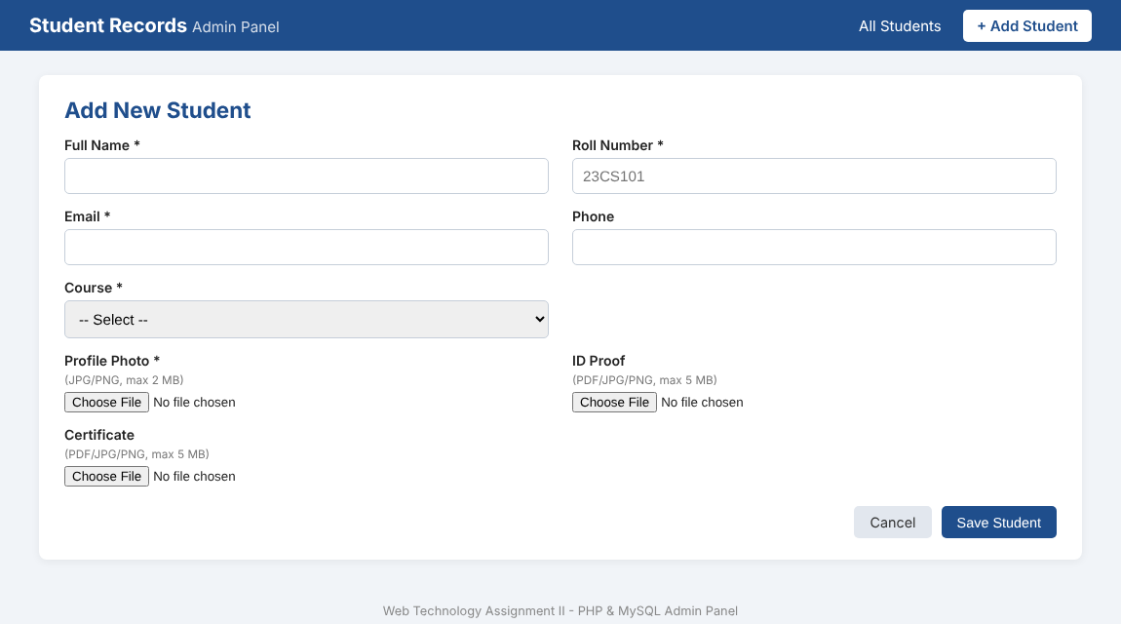
Figure 8: Add New Student page (add.php)
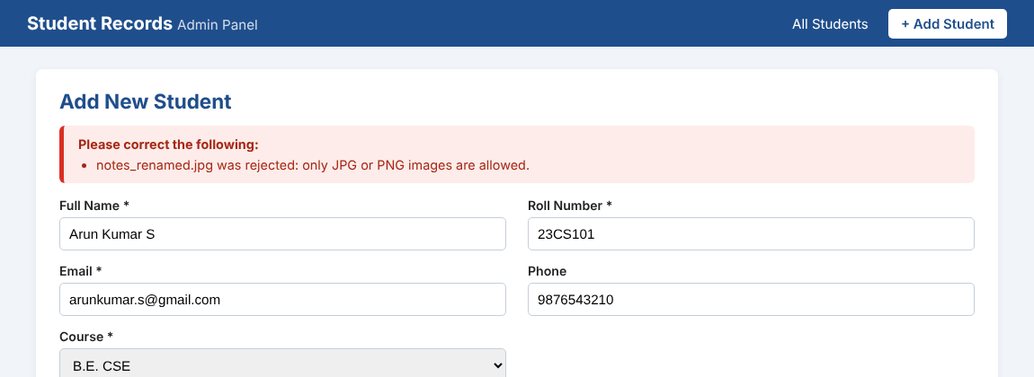
Figure 9: A text file renamed as notes_renamed.jpg is rejected by the MIME type check
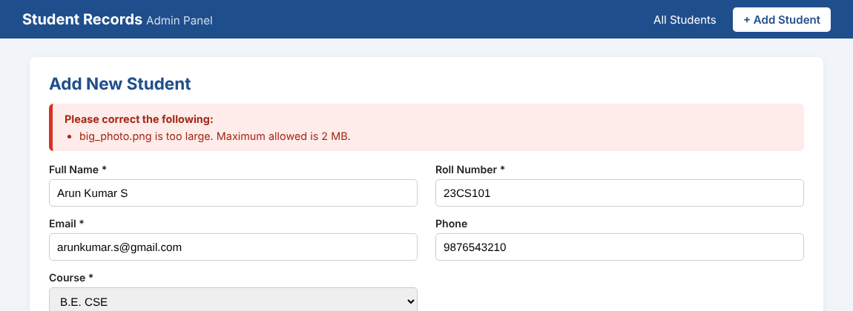
Figure 10: A 6 MB photo is rejected by the size check
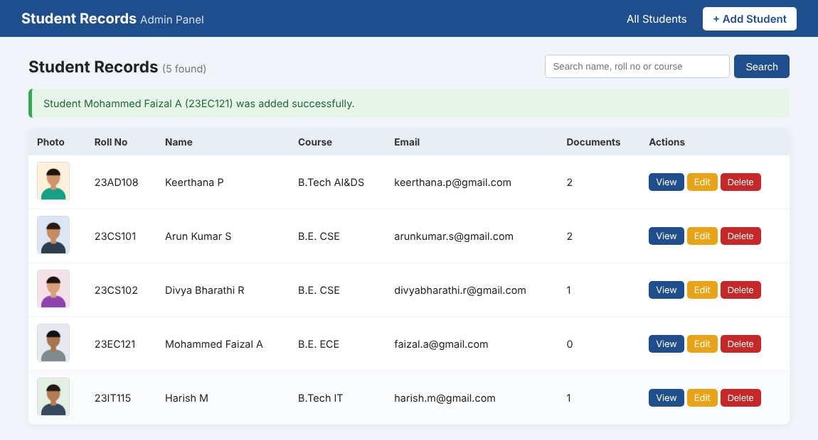
Figure 11: Student list (index.php) after adding five students, with photo thumbnails and document count
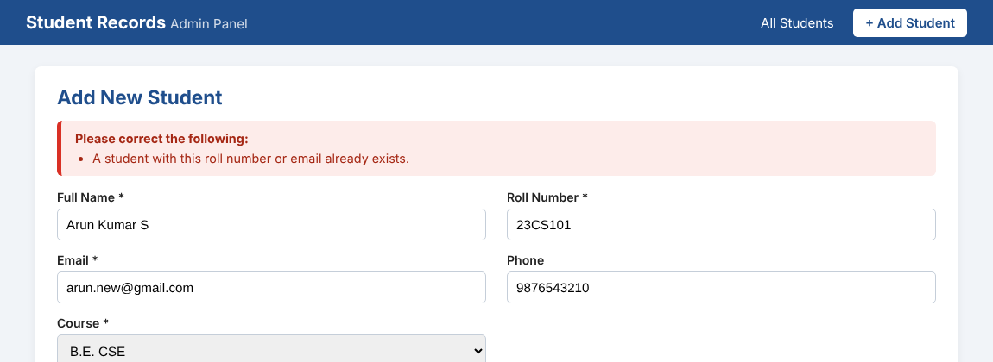
Figure 12: Trying to add roll number 23CS101 again gives a duplicate error
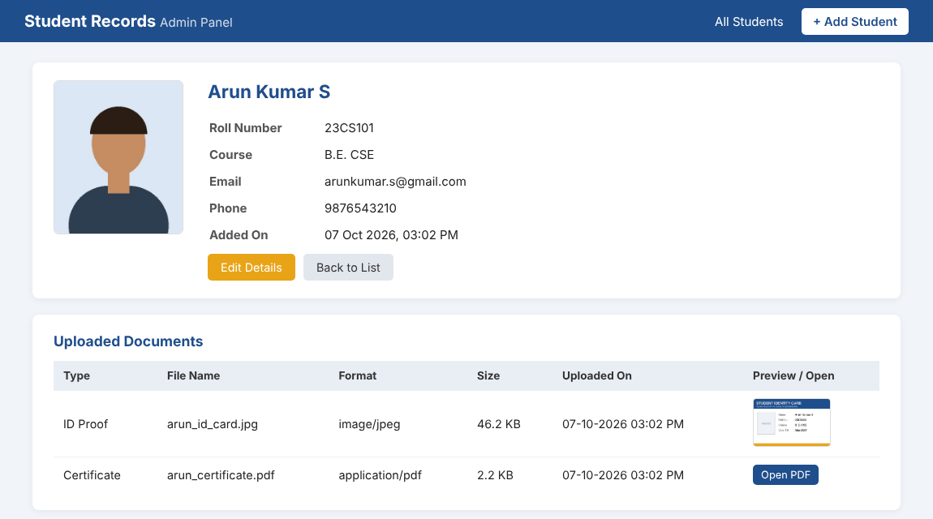
Figure 13: View page (view.php) showing the profile photo and the uploaded documents with their metadata
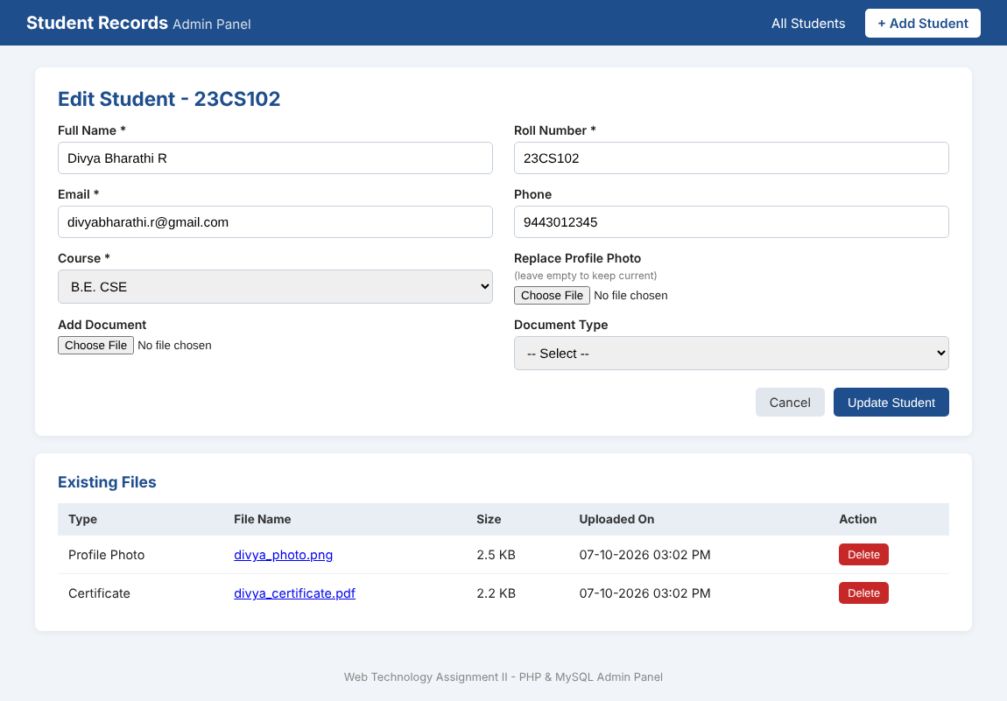
Figure 14: Edit page (edit.php) with the list of existing files
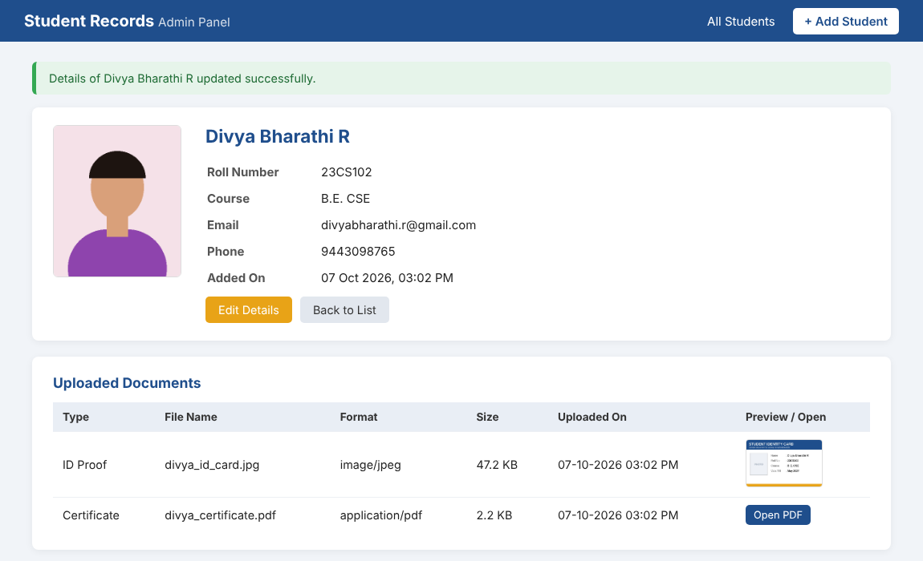
Figure 15: After update: phone number changed and an ID proof added for 23CS102
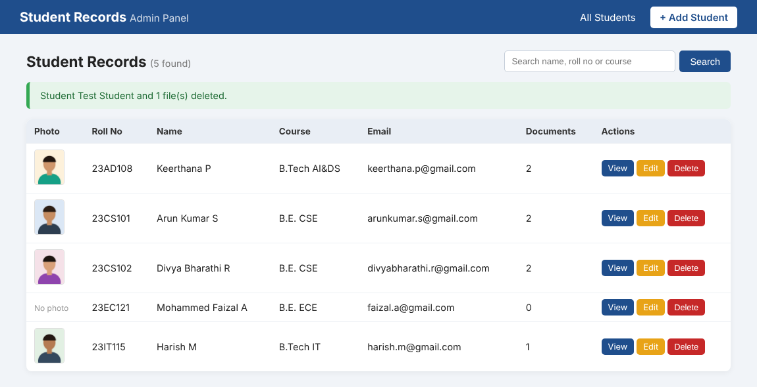
Figure 16: After deleting a test student. The photo of 23EC121 was also removed through the Edit page, so it shows No photo
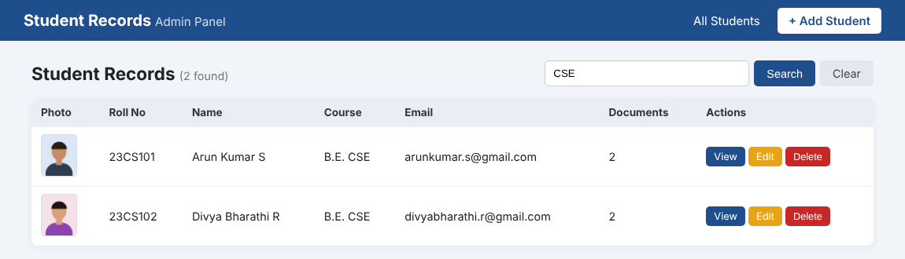
Figure 17: Search by course (CSE)

7. Question 3 - Student Profile Portal using Servlets

7.1 Requirement
Develop Servlet pages for the front end portal that connect to MySQL using JDBC to fetch student details and file paths, retrieve and stream the images and documents from the folder where they are stored, display the student profiles dynamically in HTML/JSP pages with <img> tags pointing to the Servlet, use looping and conditional logic to list the students and their files, and use session handling so that only logged-in users can use the portal.

7.2 Design and Request Flow
I followed a simple MVC style. The servlets act as controllers, the DAO classes do all the JDBC work, the model classes (Student and StudentFile) carry the data, and the JSP pages only display it. The JSP files are kept inside WEB-INF/views. Anything inside WEB-INF cannot be opened directly from the browser, so nobody can skip the servlet and the login check by typing the address of a JSP.
What happens when the student list is opened:
- The browser asks for /students. AuthFilter runs first and checks the session. If nobody is logged in, it redirects to /login.
- StudentListServlet calls StudentDAO.getAllStudents(), which runs the JDBC query and returns a List<Student>.
- The servlet keeps the list as a request attribute and forwards the request to students.jsp.
- students.jsp loops through the list and writes one card for each student. The photo is written as <img src="file?id=8">.
- The browser then asks for /file?id=8. AuthFilter checks the session again, FileServlet reads the path of file 8 from the database and streams the bytes of the image.
Table 6: Classes and files of the Servlet portal
Class / file | Role
DBConnection | Loads the JDBC driver and gives a connection to college_db
StudentDAO | Queries for the student list (with search), one student, and one file
UserDAO | Checks the username and password for login
Student, StudentFile | Model classes, with helper methods like getProfilePhoto(), getDocuments(), isImage()
LoginServlet | Shows the login page, checks the user and creates the session
LogoutServlet | Invalidates the session
StudentListServlet | Gets the list of students (and search) and forwards to students.jsp
ProfileServlet | Gets one student with files and forwards to profile.jsp
FileServlet | Streams an image or document from the uploads folder
AuthFilter | Blocks the protected URLs when the user is not logged in
HtmlUtil | Escapes text before it is printed in a JSP
login.jsp, students.jsp, profile.jsp | View pages
web.xml | Servlet and filter mappings, upload folder path, session settings

7.3 Source Code
File: q3_servlet_portal/src/main/java/com/kpr/portal/dao/DBConnection.java
package com.kpr.portal.dao;

import java.sql.Connection;
import java.sql.DriverManager;
import java.sql.SQLException;

/**
* Gives a JDBC connection to the same college_db database used by the PHP admin panel.
* mysql-connector-j jar must be present inside WEB-INF/lib.
*/
public class DBConnection {

private static final String URL =
"jdbc:mysql://localhost:3306/college_db?useSSL=false&serverTimezone=Asia/Kolkata";
private static final String USER = "root";
private static final String PASSWORD = "";

static {
try {
// load the driver class once when this class is first used
Class.forName("com.mysql.cj.jdbc.Driver");
} catch (ClassNotFoundException e) {
throw new RuntimeException("MySQL JDBC driver not found. Copy mysql-connector-j.jar to WEB-INF/lib", e);
}
}

private DBConnection() {
// only static method, so no object needed
}

public static Connection getConnection() throws SQLException {
return DriverManager.getConnection(URL, USER, PASSWORD);
}
}

File: q3_servlet_portal/src/main/java/com/kpr/portal/model/StudentFile.java
package com.kpr.portal.model;

import java.sql.Timestamp;

/** One row of the student_files table (metadata of an uploaded image / document). */
public class StudentFile {

private int fileId;
private int studentId;
private String category; // PROFILE, ID_PROOF or CERTIFICATE
private String originalName;
private String filePath; // relative path inside the uploads folder
private String fileType; // MIME type
private long fileSize;
private Timestamp uploadDate;

// ----- helper methods used in the JSP -----

public boolean isImage() {
return fileType != null && fileType.startsWith("image/");
}

public boolean isPdf() {
return "application/pdf".equals(fileType);
}

public String getCategoryLabel() {
switch (category) {
case "PROFILE": return "Profile Photo";
case "ID_PROOF": return "ID Proof";
default: return "Certificate";
}
}

public String getReadableSize() {
if (fileSize >= 1024 * 1024) {
return String.format("%.2f MB", fileSize / (1024.0 * 1024));
}
return String.format("%.1f KB", fileSize / 1024.0);
}

// ----- getters and setters -----

public int getFileId() { return fileId; }
public void setFileId(int fileId) { this.fileId = fileId; }

public int getStudentId() { return studentId; }
public void setStudentId(int studentId) { this.studentId = studentId; }

public String getCategory() { return category; }
public void setCategory(String category) { this.category = category; }

public String getOriginalName() { return originalName; }
public void setOriginalName(String originalName) { this.originalName = originalName; }

public String getFilePath() { return filePath; }
public void setFilePath(String filePath) { this.filePath = filePath; }

public String getFileType() { return fileType; }
public void setFileType(String fileType) { this.fileType = fileType; }

public long getFileSize() { return fileSize; }
public void setFileSize(long fileSize) { this.fileSize = fileSize; }

public Timestamp getUploadDate() { return uploadDate; }
public void setUploadDate(Timestamp uploadDate) { this.uploadDate = uploadDate; }
}

File: q3_servlet_portal/src/main/java/com/kpr/portal/model/Student.java
package com.kpr.portal.model;

import java.sql.Timestamp;
import java.util.ArrayList;
import java.util.List;

/** Student details along with the list of files uploaded for that student. */
public class Student {

private int id;
private String name;
private String rollNo;
private String email;
private String phone;
private String course;
private Timestamp createdAt;
private List<StudentFile> files = new ArrayList<>();

/** returns the profile photo or null if the student has no photo */
public StudentFile getProfilePhoto() {
for (StudentFile f : files) {
if ("PROFILE".equals(f.getCategory())) {
return f;
}
}
return null;
}

/** all files except the profile photo (ID proof, certificates) */
public List<StudentFile> getDocuments() {
List<StudentFile> docs = new ArrayList<>();
for (StudentFile f : files) {
if (!"PROFILE".equals(f.getCategory())) {
docs.add(f);
}
}
return docs;
}

/** first letters of the name, shown when there is no photo. "Arun Kumar S" -> "AK" */
public String getInitials() {
StringBuilder sb = new StringBuilder();
for (String part : name.trim().split("\\s+")) {
if (!part.isEmpty() && sb.length() < 2) {
sb.append(Character.toUpperCase(part.charAt(0)));
}
}
return sb.toString();
}

public void addFile(StudentFile f) {
files.add(f);
}

// ----- getters and setters -----

public int getId() { return id; }
public void setId(int id) { this.id = id; }

public String getName() { return name; }
public void setName(String name) { this.name = name; }

public String getRollNo() { return rollNo; }
public void setRollNo(String rollNo) { this.rollNo = rollNo; }

public String getEmail() { return email; }
public void setEmail(String email) { this.email = email; }

public String getPhone() { return phone; }
public void setPhone(String phone) { this.phone = phone; }

public String getCourse() { return course; }
public void setCourse(String course) { this.course = course; }

public Timestamp getCreatedAt() { return createdAt; }
public void setCreatedAt(Timestamp createdAt) { this.createdAt = createdAt; }

public List<StudentFile> getFiles() { return files; }
}

File: q3_servlet_portal/src/main/java/com/kpr/portal/dao/StudentDAO.java
package com.kpr.portal.dao;

import com.kpr.portal.model.Student;
import com.kpr.portal.model.StudentFile;

import java.sql.Connection;
import java.sql.PreparedStatement;
import java.sql.ResultSet;
import java.sql.SQLException;
import java.util.ArrayList;
import java.util.LinkedHashMap;
import java.util.List;
import java.util.Map;

/** All database work related to students and their files is kept in this class. */
public class StudentDAO {

// one query fetches students together with their files using LEFT JOIN,
// so a student without any file still comes in the result
private static final String BASE_QUERY =
"SELECT s.id, s.name, s.roll_no, s.email, s.phone, s.course, s.created_at, "
+ " f.file_id, f.file_category, f.original_name, f.file_path, f.file_type, "
+ " f.file_size, f.upload_date "
+ "FROM students s "
+ "LEFT JOIN student_files f ON f.student_id = s.id ";

/** returns all students (or only matching ones when search text is given) */
public List<Student> getAllStudents(String search) throws SQLException {
boolean hasSearch = search != null && !search.trim().isEmpty();

String sql = BASE_QUERY
+ (hasSearch ? "WHERE s.name LIKE ? OR s.roll_no LIKE ? OR s.course LIKE ? " : "")
+ "ORDER BY s.roll_no, f.upload_date";

try (Connection con = DBConnection.getConnection();
PreparedStatement ps = con.prepareStatement(sql)) {

if (hasSearch) {
String like = "%" + search.trim() + "%";
ps.setString(1, like);
ps.setString(2, like);
ps.setString(3, like);
}

try (ResultSet rs = ps.executeQuery()) {
return buildStudentList(rs);
}
}
}

/** returns one student with files, or null when the id does not exist */
public Student getStudentById(int id) throws SQLException {
String sql = BASE_QUERY + "WHERE s.id = ? ORDER BY f.upload_date";

try (Connection con = DBConnection.getConnection();
PreparedStatement ps = con.prepareStatement(sql)) {
ps.setInt(1, id);
try (ResultSet rs = ps.executeQuery()) {
List<Student> list = buildStudentList(rs);
return list.isEmpty() ? null : list.get(0);
}
}
}

/** used by FileServlet to find where a file is stored */
public StudentFile getFileById(int fileId) throws SQLException {
String sql = "SELECT * FROM student_files WHERE file_id = ?";

try (Connection con = DBConnection.getConnection();
PreparedStatement ps = con.prepareStatement(sql)) {
ps.setInt(1, fileId);
try (ResultSet rs = ps.executeQuery()) {
if (rs.next()) {
return mapFile(rs);
}
}
}
return null;
}

/*
* The JOIN gives one row per file, so the same student comes many times.
* A LinkedHashMap (keeps insertion order) is used to group the rows by student id.
*/
private List<Student> buildStudentList(ResultSet rs) throws SQLException {
Map<Integer, Student> map = new LinkedHashMap<>();

while (rs.next()) {
int id = rs.getInt("id");
Student s = map.get(id);

if (s == null) { // first row of this student
s = new Student();
s.setId(id);
s.setName(rs.getString("name"));
s.setRollNo(rs.getString("roll_no"));
s.setEmail(rs.getString("email"));
s.setPhone(rs.getString("phone"));
s.setCourse(rs.getString("course"));
s.setCreatedAt(rs.getTimestamp("created_at"));
map.put(id, s);
}

rs.getInt("file_id");
if (!rs.wasNull()) { // file_id is NULL when the student has no files
s.addFile(mapFile(rs));
}
}
return new ArrayList<>(map.values());
}

private StudentFile mapFile(ResultSet rs) throws SQLException {
StudentFile f = new StudentFile();
f.setFileId(rs.getInt("file_id"));
f.setCategory(rs.getString("file_category"));
f.setOriginalName(rs.getString("original_name"));
f.setFilePath(rs.getString("file_path"));
f.setFileType(rs.getString("file_type"));
f.setFileSize(rs.getLong("file_size"));
f.setUploadDate(rs.getTimestamp("upload_date"));
return f;
}
}

File: q3_servlet_portal/src/main/java/com/kpr/portal/dao/UserDAO.java
package com.kpr.portal.dao;

import java.sql.Connection;
import java.sql.PreparedStatement;
import java.sql.ResultSet;
import java.sql.SQLException;

/** Checks the login details against the portal_users table. */
public class UserDAO {

/**
* Returns the full name of the user if username and password are correct, otherwise null.
* Password is never stored in plain text, MySQL's SHA2() hashes the typed password
* and it is compared with the stored hash.
*/
public String validateUser(String username, String password) throws SQLException {
String sql = "SELECT full_name FROM portal_users WHERE username = ? AND password_hash = SHA2(?, 256)";

try (Connection con = DBConnection.getConnection();
PreparedStatement ps = con.prepareStatement(sql)) {
ps.setString(1, username);
ps.setString(2, password);
try (ResultSet rs = ps.executeQuery()) {
return rs.next() ? rs.getString("full_name") : null;
}
}
}
}

File: q3_servlet_portal/src/main/java/com/kpr/portal/util/HtmlUtil.java
package com.kpr.portal.util;

/** Escapes text before printing it in a JSP, so that HTML / script inside data is not executed. */
public class HtmlUtil {

public static String esc(String text) {
if (text == null) {
return "";
}
return text.replace("&", "&amp;")
.replace("<", "&lt;")
.replace(">", "&gt;")
.replace("\"", "&quot;")
.replace("'", "&#39;");
}
}

File: q3_servlet_portal/src/main/java/com/kpr/portal/servlet/LoginServlet.java
package com.kpr.portal.servlet;

import com.kpr.portal.dao.UserDAO;

import jakarta.servlet.ServletException;
import jakarta.servlet.http.HttpServlet;
import jakarta.servlet.http.HttpServletRequest;
import jakarta.servlet.http.HttpServletResponse;
import jakarta.servlet.http.HttpSession;
import java.io.IOException;
import java.sql.SQLException;

/** Shows the login page (GET) and checks the username / password (POST). */
public class LoginServlet extends HttpServlet {

private final UserDAO userDAO = new UserDAO();

@Override
protected void doGet(HttpServletRequest request, HttpServletResponse response)
throws ServletException, IOException {

// already logged in? then no need to show the login page again
HttpSession session = request.getSession(false);
if (session != null && session.getAttribute("username") != null) {
response.sendRedirect(request.getContextPath() + "/students");
return;
}
request.getRequestDispatcher("/WEB-INF/views/login.jsp").forward(request, response);
}

@Override
protected void doPost(HttpServletRequest request, HttpServletResponse response)
throws ServletException, IOException {

String username = request.getParameter("username");
String password = request.getParameter("password");

// basic empty check before going to the database
if (username == null || username.trim().isEmpty() || password == null || password.isEmpty()) {
request.setAttribute("error", "Please enter both username and password.");
request.getRequestDispatcher("/WEB-INF/views/login.jsp").forward(request, response);
return;
}

try {
String fullName = userDAO.validateUser(username.trim(), password);

if (fullName != null) {
// remove any old session and create a fresh one (avoids session fixation)
HttpSession old = request.getSession(false);
if (old != null) {
old.invalidate();
}
HttpSession session = request.getSession(true);
session.setAttribute("username", username.trim());
session.setAttribute("fullName", fullName);
session.setMaxInactiveInterval(15 * 60); // auto logout after 15 minutes idle

response.sendRedirect(request.getContextPath() + "/students");
} else {
request.setAttribute("error", "Invalid username or password.");
request.getRequestDispatcher("/WEB-INF/views/login.jsp").forward(request, response);
}
} catch (SQLException e) {
log("Login failed due to DB error", e);
request.setAttribute("error", "Database is not reachable right now. Try again later.");
request.getRequestDispatcher("/WEB-INF/views/login.jsp").forward(request, response);
}
}
}

File: q3_servlet_portal/src/main/java/com/kpr/portal/servlet/LogoutServlet.java
package com.kpr.portal.servlet;

import jakarta.servlet.ServletException;
import jakarta.servlet.http.HttpServlet;
import jakarta.servlet.http.HttpServletRequest;
import jakarta.servlet.http.HttpServletResponse;
import jakarta.servlet.http.HttpSession;
import java.io.IOException;

/** Ends the session and sends the user back to the login page. */
public class LogoutServlet extends HttpServlet {

@Override
protected void doGet(HttpServletRequest request, HttpServletResponse response)
throws ServletException, IOException {

HttpSession session = request.getSession(false); // false = don't create a new one
if (session != null) {
session.invalidate();
}
response.sendRedirect(request.getContextPath() + "/login?msg=loggedout");
}
}

File: q3_servlet_portal/src/main/java/com/kpr/portal/servlet/StudentListServlet.java
package com.kpr.portal.servlet;

import com.kpr.portal.dao.StudentDAO;
import com.kpr.portal.model.Student;

import jakarta.servlet.ServletException;
import jakarta.servlet.http.HttpServlet;
import jakarta.servlet.http.HttpServletRequest;
import jakarta.servlet.http.HttpServletResponse;
import java.io.IOException;
import java.sql.SQLException;
import java.util.List;

/** Fetches the list of students from MySQL and passes it to students.jsp */
public class StudentListServlet extends HttpServlet {

private final StudentDAO studentDAO = new StudentDAO();

@Override
protected void doGet(HttpServletRequest request, HttpServletResponse response)
throws ServletException, IOException {

String search = request.getParameter("q");

try {
List<Student> students = studentDAO.getAllStudents(search);
request.setAttribute("students", students);
request.setAttribute("q", search == null ? "" : search);
} catch (SQLException e) {
log("Could not load students", e);
request.setAttribute("error", "Unable to load student records. Please check the database connection.");
}

request.getRequestDispatcher("/WEB-INF/views/students.jsp").forward(request, response);
}
}

File: q3_servlet_portal/src/main/java/com/kpr/portal/servlet/ProfileServlet.java
package com.kpr.portal.servlet;

import com.kpr.portal.dao.StudentDAO;
import com.kpr.portal.model.Student;

import jakarta.servlet.ServletException;
import jakarta.servlet.http.HttpServlet;
import jakarta.servlet.http.HttpServletRequest;
import jakarta.servlet.http.HttpServletResponse;
import java.io.IOException;
import java.sql.SQLException;

/** Shows the full profile of one student: /profile?id=3 */
public class ProfileServlet extends HttpServlet {

private final StudentDAO studentDAO = new StudentDAO();

@Override
protected void doGet(HttpServletRequest request, HttpServletResponse response)
throws ServletException, IOException {

int id;
try {
id = Integer.parseInt(request.getParameter("id"));
} catch (NumberFormatException e) {
// id missing or not a number
response.sendRedirect(request.getContextPath() + "/students");
return;
}

try {
Student student = studentDAO.getStudentById(id);
if (student == null) {
response.sendError(HttpServletResponse.SC_NOT_FOUND, "Student not found");
return;
}
request.setAttribute("student", student);
request.getRequestDispatcher("/WEB-INF/views/profile.jsp").forward(request, response);

} catch (SQLException e) {
log("Could not load profile " + id, e);
response.sendError(HttpServletResponse.SC_INTERNAL_SERVER_ERROR, "Database error");
}
}
}

File: q3_servlet_portal/src/main/java/com/kpr/portal/servlet/FileServlet.java
package com.kpr.portal.servlet;

import com.kpr.portal.dao.StudentDAO;
import com.kpr.portal.model.StudentFile;

import jakarta.servlet.ServletException;
import jakarta.servlet.http.HttpServlet;
import jakarta.servlet.http.HttpServletRequest;
import jakarta.servlet.http.HttpServletResponse;
import java.io.File;
import java.io.FileInputStream;
import java.io.IOException;
import java.io.InputStream;
import java.io.OutputStream;
import java.net.URLEncoder;
import java.nio.charset.StandardCharsets;
import java.sql.SQLException;

/**
* Streams an uploaded image / document to the browser.
* Usage in HTML: <img src="file?id=12"> or <a href="file?id=15&download=1">
* Only the file id comes from the browser, the real path is taken from the database,
* so nobody can read other files on the server by changing the URL.
*/
public class FileServlet extends HttpServlet {

private final StudentDAO studentDAO = new StudentDAO();
private File uploadFolder;

@Override
public void init() throws ServletException {
// folder path comes from web.xml (context-param "uploadDirectory")
String dir = getServletContext().getInitParameter("uploadDirectory");
if (dir == null) {
throw new ServletException("uploadDirectory is not set in web.xml");
}
uploadFolder = new File(dir);
}

@Override
protected void doGet(HttpServletRequest request, HttpServletResponse response)
throws ServletException, IOException {

int fileId;
try {
fileId = Integer.parseInt(request.getParameter("id"));
} catch (NumberFormatException e) {
response.sendError(HttpServletResponse.SC_BAD_REQUEST, "Invalid file id");
return;
}

StudentFile meta;
try {
meta = studentDAO.getFileById(fileId);
} catch (SQLException e) {
log("DB error while reading file " + fileId, e);
response.sendError(HttpServletResponse.SC_INTERNAL_SERVER_ERROR);
return;
}

if (meta == null) {
response.sendError(HttpServletResponse.SC_NOT_FOUND, "File record not found");
return;
}

File file = new File(uploadFolder, meta.getFilePath());

// extra safety: the final path must still be inside the uploads folder
if (!file.getCanonicalPath().startsWith(uploadFolder.getCanonicalPath() + File.separator)) {
response.sendError(HttpServletResponse.SC_FORBIDDEN);
return;
}
if (!file.isFile()) {
response.sendError(HttpServletResponse.SC_NOT_FOUND, "File missing on server");
return;
}

// tell the browser what is coming
response.setContentType(meta.getFileType());
response.setContentLengthLong(file.length());

boolean download = "1".equals(request.getParameter("download"));
String encodedName = URLEncoder.encode(meta.getOriginalName(), StandardCharsets.UTF_8).replace("+", "%20");
response.setHeader("Content-Disposition",
(download ? "attachment" : "inline") + "; filename*=UTF-8''" + encodedName);

// copy the file to the response in small chunks (does not load the whole file in memory)
try (InputStream in = new FileInputStream(file);
OutputStream out = response.getOutputStream()) {
byte[] buffer = new byte[8192];
int bytesRead;
while ((bytesRead = in.read(buffer)) != -1) {
out.write(buffer, 0, bytesRead);
}
}
}
}

File: q3_servlet_portal/src/main/java/com/kpr/portal/filter/AuthFilter.java
package com.kpr.portal.filter;

import jakarta.servlet.Filter;
import jakarta.servlet.FilterChain;
import jakarta.servlet.ServletException;
import jakarta.servlet.ServletRequest;
import jakarta.servlet.ServletResponse;
import jakarta.servlet.http.HttpServletRequest;
import jakarta.servlet.http.HttpServletResponse;
import jakarta.servlet.http.HttpSession;
import java.io.IOException;

/**
* Runs before every protected URL (see filter-mapping in web.xml).
* If there is no logged-in user in the session, the request is sent to the login page.
*/
public class AuthFilter implements Filter {

@Override
public void doFilter(ServletRequest req, ServletResponse res, FilterChain chain)
throws IOException, ServletException {

HttpServletRequest request = (HttpServletRequest) req;
HttpServletResponse response = (HttpServletResponse) res;

HttpSession session = request.getSession(false);
boolean loggedIn = session != null && session.getAttribute("username") != null;

if (!loggedIn) {
response.sendRedirect(request.getContextPath() + "/login?msg=required");
return;
}

// stop the browser from caching protected pages,
// otherwise pressing Back after logout would still show the data
response.setHeader("Cache-Control", "no-cache, no-store, must-revalidate");
response.setHeader("Pragma", "no-cache");
response.setDateHeader("Expires", 0);

chain.doFilter(request, response); // user is logged in, continue to the servlet
}
}

File: q3_servlet_portal/src/main/webapp/WEB-INF/web.xml
<?xml version="1.0" encoding="UTF-8"?>
<!-- web.xml - deployment descriptor for the Student Profile Portal (Tomcat 10 / Jakarta EE) -->
<web-app xmlns="https://jakarta.ee/xml/ns/jakartaee"
xmlns:xsi="http://www.w3.org/2001/XMLSchema-instance"
xsi:schemaLocation="https://jakarta.ee/xml/ns/jakartaee https://jakarta.ee/xml/ns/jakartaee/web-app_6_0.xsd"
version="6.0">

<display-name>Student Profile Portal</display-name>

<!-- folder where the PHP admin panel saves the uploaded files.
Both projects share the same folder, so files uploaded from PHP can be shown here. -->
<context-param>
<param-name>uploadDirectory</param-name>
<param-value>C:/xampp/htdocs/student_admin/uploads</param-value>
</context-param>

<!-- ===================== Servlets ===================== -->
<servlet>
<servlet-name>LoginServlet</servlet-name>
<servlet-class>com.kpr.portal.servlet.LoginServlet</servlet-class>
</servlet>
<servlet-mapping>
<servlet-name>LoginServlet</servlet-name>
<url-pattern>/login</url-pattern>
</servlet-mapping>

<servlet>
<servlet-name>LogoutServlet</servlet-name>
<servlet-class>com.kpr.portal.servlet.LogoutServlet</servlet-class>
</servlet>
<servlet-mapping>
<servlet-name>LogoutServlet</servlet-name>
<url-pattern>/logout</url-pattern>
</servlet-mapping>

<servlet>
<servlet-name>StudentListServlet</servlet-name>
<servlet-class>com.kpr.portal.servlet.StudentListServlet</servlet-class>
</servlet>
<servlet-mapping>
<servlet-name>StudentListServlet</servlet-name>
<url-pattern>/students</url-pattern>
</servlet-mapping>

<servlet>
<servlet-name>ProfileServlet</servlet-name>
<servlet-class>com.kpr.portal.servlet.ProfileServlet</servlet-class>
</servlet>
<servlet-mapping>
<servlet-name>ProfileServlet</servlet-name>
<url-pattern>/profile</url-pattern>
</servlet-mapping>

<servlet>
<servlet-name>FileServlet</servlet-name>
<servlet-class>com.kpr.portal.servlet.FileServlet</servlet-class>
</servlet>
<servlet-mapping>
<servlet-name>FileServlet</servlet-name>
<url-pattern>/file</url-pattern>
</servlet-mapping>

<!-- ===================== Login check ===================== -->
<!-- every URL listed here can be opened only after login -->
<filter>
<filter-name>AuthFilter</filter-name>
<filter-class>com.kpr.portal.filter.AuthFilter</filter-class>
</filter>
<filter-mapping>
<filter-name>AuthFilter</filter-name>
<url-pattern>/students</url-pattern>
<url-pattern>/profile</url-pattern>
<url-pattern>/file</url-pattern>
</filter-mapping>

<!-- ===================== Session settings ===================== -->
<session-config>
<session-timeout>15</session-timeout> <!-- minutes -->
<cookie-config>
<http-only>true</http-only> <!-- JavaScript cannot read the session cookie -->
</cookie-config>
<tracking-mode>COOKIE</tracking-mode> <!-- no jsessionid in the URL -->
</session-config>

<welcome-file-list>
<welcome-file>index.jsp</welcome-file>
</welcome-file-list>

</web-app>

File: q3_servlet_portal/src/main/webapp/index.jsp
<%-- index.jsp - opening the project URL directly takes the user to the login servlet --%>
<% response.sendRedirect(request.getContextPath() + "/login"); %>

File: q3_servlet_portal/src/main/webapp/WEB-INF/views/login.jsp
<%@ page contentType="text/html; charset=UTF-8" pageEncoding="UTF-8" %>
<%@ page import="com.kpr.portal.util.HtmlUtil" %>
<%
// message from the servlet (wrong password etc.)
String error = (String) request.getAttribute("error");
// message passed in the URL by the filter / logout servlet
String msg = request.getParameter("msg");
%>
<!DOCTYPE html>
<html lang="en">
<head>
<meta charset="UTF-8">
<meta name="viewport" content="width=device-width, initial-scale=1.0">
<title>Login | Student Profile Portal</title>
<link rel="stylesheet" href="<%= request.getContextPath() %>/css/portal.css">
</head>
<body class="login-page">
<div class="login-box">
<h1>Student Profile Portal</h1>
<p class="sub">KPR Institute of Engineering and Technology</p>

<% if (error != null) { %>
<div class="alert error"><%= HtmlUtil.esc(error) %></div>
<% } else if ("required".equals(msg)) { %>
<div class="alert info">Please login to continue.</div>
<% } else if ("loggedout".equals(msg)) { %>
<div class="alert success">You have been logged out successfully.</div>
<% } %>

<form action="<%= request.getContextPath() %>/login" method="post">
<label for="username">Username</label>
<input type="text" id="username" name="username" required autofocus
value="<%= HtmlUtil.esc(request.getParameter("username")) %>">

<label for="password">Password</label>
<input type="password" id="password" name="password" required>

<button type="submit" class="btn full">Login</button>
</form>
</div>
</body>
</html>

File: q3_servlet_portal/src/main/webapp/WEB-INF/views/students.jsp
<%@ page contentType="text/html; charset=UTF-8" pageEncoding="UTF-8" %>
<%@ page import="java.util.List, com.kpr.portal.model.Student, com.kpr.portal.model.StudentFile" %>
<%@ page import="com.kpr.portal.util.HtmlUtil" %>
<%
// data sent by StudentListServlet
@SuppressWarnings("unchecked")
List<Student> students = (List<Student>) request.getAttribute("students");
String q = (String) request.getAttribute("q");
String error = (String) request.getAttribute("error");
String ctx = request.getContextPath();
%>
<!DOCTYPE html>
<html lang="en">
<head>
<meta charset="UTF-8">
<meta name="viewport" content="width=device-width, initial-scale=1.0">
<title>Students | Student Profile Portal</title>
<link rel="stylesheet" href="<%= ctx %>/css/portal.css">
</head>
<body>
<header class="topbar">
<div class="brand">Student Profile Portal</div>
<div class="user">
Welcome, <strong><%= HtmlUtil.esc((String) session.getAttribute("fullName")) %></strong>
<a href="<%= ctx %>/logout" class="btn btn-light btn-sm">Logout</a>
</div>
</header>

<main class="wrap">
<div class="page-head">
<h2>Student Profiles</h2>
<form action="<%= ctx %>/students" method="get" class="search">
<input type="text" name="q" value="<%= HtmlUtil.esc(q) %>" placeholder="Search by name, roll no or course">
<button type="submit" class="btn">Search</button>
</form>
</div>

<% if (error != null) { %>
<div class="alert error"><%= HtmlUtil.esc(error) %></div>

<% } else if (students == null || students.isEmpty()) { %>
<p class="empty">No students found<%= (q != null && !q.isEmpty()) ? " for \"" + HtmlUtil.esc(q) + "\"" : "" %>.</p>

<% } else { %>
<p class="count">Showing <%= students.size() %> student(s)</p>

<div class="grid">
<% // loop through every student and build one card for each
for (Student s : students) {
StudentFile photo = s.getProfilePhoto();
List<StudentFile> docs = s.getDocuments();
%>
<div class="card">
<% if (photo != null) { %>
<!-- the image is not a direct path, it is served by FileServlet -->
<img src="<%= ctx %>/file?id=<%= photo.getFileId() %>" class="photo"
alt="Photo of <%= HtmlUtil.esc(s.getName()) %>">
<% } else { %>
<div class="avatar"><%= s.getInitials() %></div>
<% } %>

<h3><%= HtmlUtil.esc(s.getName()) %></h3>
<p class="roll"><%= HtmlUtil.esc(s.getRollNo()) %></p>
<p class="course"><%= HtmlUtil.esc(s.getCourse()) %></p>

<% if (docs.isEmpty()) { %>
<span class="badge warn">No documents</span>
<% } else { %>
<span class="badge ok"><%= docs.size() %> document<%= docs.size() > 1 ? "s" : "" %></span>
<% } %>

<a href="<%= ctx %>/profile?id=<%= s.getId() %>" class="btn full">View Profile</a>
</div>
<% } %>
</div>
<% } %>
</main>
</body>
</html>

File: q3_servlet_portal/src/main/webapp/WEB-INF/views/profile.jsp
<%@ page contentType="text/html; charset=UTF-8" pageEncoding="UTF-8" %>
<%@ page import="java.util.List, java.text.SimpleDateFormat" %>
<%@ page import="com.kpr.portal.model.Student, com.kpr.portal.model.StudentFile, com.kpr.portal.util.HtmlUtil" %>
<%
Student s = (Student) request.getAttribute("student");
StudentFile photo = s.getProfilePhoto();
List<StudentFile> docs = s.getDocuments();
SimpleDateFormat fmt = new SimpleDateFormat("dd-MM-yyyy hh:mm a");
String ctx = request.getContextPath();
%>
<!DOCTYPE html>
<html lang="en">
<head>
<meta charset="UTF-8">
<meta name="viewport" content="width=device-width, initial-scale=1.0">
<title><%= HtmlUtil.esc(s.getName()) %> | Student Profile Portal</title>
<link rel="stylesheet" href="<%= ctx %>/css/portal.css">
</head>
<body>
<header class="topbar">
<div class="brand">Student Profile Portal</div>
<div class="user">
Welcome, <strong><%= HtmlUtil.esc((String) session.getAttribute("fullName")) %></strong>
<a href="<%= ctx %>/logout" class="btn btn-light btn-sm">Logout</a>
</div>
</header>

<main class="wrap">
<a href="<%= ctx %>/students" class="back">&larr; Back to all students</a>

<section class="profile card">
<div>
<% if (photo != null) { %>
<img src="<%= ctx %>/file?id=<%= photo.getFileId() %>" class="photo big" alt="Profile photo">
<% } else { %>
<div class="avatar big"><%= s.getInitials() %></div>
<% } %>
</div>
<div class="info">
<h2><%= HtmlUtil.esc(s.getName()) %></h2>
<table class="details">
<tr><th>Roll Number</th><td><%= HtmlUtil.esc(s.getRollNo()) %></td></tr>
<tr><th>Course</th><td><%= HtmlUtil.esc(s.getCourse()) %></td></tr>
<tr><th>Email</th><td><%= HtmlUtil.esc(s.getEmail()) %></td></tr>
<tr><th>Phone</th>
<td><%= (s.getPhone() == null || s.getPhone().isEmpty()) ? "Not given" : HtmlUtil.esc(s.getPhone()) %></td></tr>
<tr><th>Registered On</th><td><%= fmt.format(s.getCreatedAt()) %></td></tr>
</table>
</div>
</section>

<section class="card">
<h3>Documents (<%= docs.size() %>)</h3>

<% if (docs.isEmpty()) { %>
<p class="empty">This student has not uploaded any documents yet.</p>
<% } else { %>
<div class="doc-grid">
<% for (StudentFile d : docs) { %>
<div class="doc">
<% if (d.isImage()) { %>
<!-- image documents are shown as thumbnails -->
<img src="<%= ctx %>/file?id=<%= d.getFileId() %>" alt="<%= HtmlUtil.esc(d.getOriginalName()) %>">
<% } else if (d.isPdf()) { %>
<!-- PDFs get a simple icon, they open in a new tab when clicked -->
<a href="<%= ctx %>/file?id=<%= d.getFileId() %>" target="_blank" class="file-icon">PDF</a>
<% } else { %>
<div class="file-icon">FILE</div>
<% } %>
<p class="doc-title"><%= d.getCategoryLabel() %></p>
<p class="doc-meta"><%= HtmlUtil.esc(d.getOriginalName()) %><br>
<%= d.getReadableSize() %> &middot; <%= fmt.format(d.getUploadDate()) %></p>
<a href="<%= ctx %>/file?id=<%= d.getFileId() %>" target="_blank" class="btn btn-sm">Open</a>
<a href="<%= ctx %>/file?id=<%= d.getFileId() %>&amp;download=1" class="btn btn-sm btn-light">Download</a>
</div>
<% } %>
</div>
<% } %>
</section>
</main>
</body>
</html>

File: q3_servlet_portal/src/main/webapp/css/portal.css
/* portal.css - styles for the Servlet / JSP student profile portal */
* { box-sizing: border-box; margin: 0; padding: 0; }

body {
font-family: "Segoe UI", Arial, sans-serif;
background: #f3f5f9;
color: #222;
}

/* ---------- login page ---------- */
.login-page {
min-height: 100vh;
display: flex;
align-items: center;
justify-content: center;
background: linear-gradient(135deg, #1f4e8c, #3a7bd5);
}
.login-box {
background: #fff;
width: 360px;
padding: 34px 30px;
border-radius: 10px;
box-shadow: 0 10px 30px rgba(0, 0, 0, 0.2);
}
.login-box h1 { font-size: 1.4rem; color: #1f4e8c; text-align: center; }
.login-box .sub { text-align: center; color: #777; font-size: 0.85rem; margin-bottom: 20px; }
.login-box label { display: block; font-weight: 600; font-size: 0.88rem; margin: 12px 0 5px; }
.login-box input {
width: 100%; padding: 10px; border: 1px solid #c5ced9; border-radius: 5px; font-size: 0.95rem;
}
.login-box .btn { margin-top: 20px; }

/* ---------- top bar ---------- */
.topbar {
background: #1f4e8c; color: #fff;
display: flex; justify-content: space-between; align-items: center;
padding: 14px 30px;
}
.brand { font-size: 1.2rem; font-weight: 700; }
.user { font-size: 0.9rem; display: flex; align-items: center; gap: 12px; }

.wrap { max-width: 1100px; margin: 25px auto; padding: 0 15px; }
.page-head { display: flex; justify-content: space-between; align-items: center; flex-wrap: wrap; gap: 10px; }
.page-head h2 { color: #1f4e8c; }
.search { display: flex; gap: 6px; }
.search input { padding: 8px 10px; border: 1px solid #c5ced9; border-radius: 5px; width: 270px; }
.count { color: #666; font-size: 0.88rem; margin: 12px 0; }
.empty { color: #777; padding: 20px 0; }
.back { display: inline-block; margin-bottom: 14px; color: #1f4e8c; text-decoration: none; }

/* ---------- buttons ---------- */
.btn {
display: inline-block; background: #1f4e8c; color: #fff; border: none;
padding: 8px 16px; border-radius: 5px; text-decoration: none; cursor: pointer;
font-size: 0.9rem; text-align: center;
}
.btn:hover { opacity: 0.9; }
.btn.full { display: block; width: 100%; }
.btn-light { background: #e2e7ee; color: #333; }
.btn-sm { padding: 5px 10px; font-size: 0.8rem; }

/* ---------- student cards ---------- */
.grid { display: grid; grid-template-columns: repeat(auto-fill, minmax(200px, 1fr)); gap: 18px; }
.card {
background: #fff; border-radius: 10px; padding: 18px;
box-shadow: 0 2px 10px rgba(0, 0, 0, 0.06); text-align: center;
}
.card h3 { font-size: 1rem; margin-top: 10px; }
.roll { color: #1f4e8c; font-weight: 600; font-size: 0.9rem; }
.course { color: #666; font-size: 0.85rem; margin-bottom: 8px; }
.card .btn.full { margin-top: 12px; }

.photo { display: block; margin: 0 auto; width: 100px; height: 120px; object-fit: cover; border-radius: 8px; border: 1px solid #ddd; }
.avatar {
width: 100px; height: 120px; margin: 0 auto; border-radius: 8px;
background: #d9e3f1; color: #1f4e8c; font-size: 2rem; font-weight: 700;
display: flex; align-items: center; justify-content: center;
}
.photo.big, .avatar.big { width: 170px; height: 200px; }

.badge { display: inline-block; font-size: 0.75rem; padding: 3px 10px; border-radius: 12px; }
.badge.ok { background: #e6f4ea; color: #1e6b34; }
.badge.warn { background: #fff4e0; color: #9a6200; }

/* ---------- profile page ---------- */
.profile { display: flex; gap: 30px; text-align: left; margin-bottom: 20px; }
.profile .info { flex: 1; }
.profile h2 { color: #1f4e8c; margin-bottom: 10px; }
.details th { text-align: left; padding: 7px 24px 7px 0; color: #555; width: 150px; }
.details td { padding: 7px 0; }

section.card { text-align: left; }
section.card h3 { color: #1f4e8c; margin: 0 0 14px; font-size: 1.1rem; }
.doc-grid { display: grid; grid-template-columns: repeat(auto-fill, minmax(230px, 1fr)); gap: 16px; }
.doc { border: 1px solid #e3e7ee; border-radius: 8px; padding: 12px; text-align: center; }
.doc img { display: block; width: 100%; height: 170px; object-fit: contain; border: 1px solid #eee; background: #fafafa; }
.file-icon {
height: 170px; display: flex; align-items: center; justify-content: center;
background: #fdecea; color: #c62828; font-weight: 700; font-size: 1.8rem; border-radius: 6px;
text-decoration: none; border: 1px solid #f5c6c2;
}
.doc-title { font-weight: 600; margin-top: 8px; }
.doc-meta { font-size: 0.78rem; color: #777; margin: 4px 0 8px; word-break: break-all; }

/* ---------- messages ---------- */
.alert { padding: 10px 14px; border-radius: 6px; font-size: 0.88rem; margin-bottom: 10px; }
.alert.error { background: #fdecea; color: #a52714; }
.alert.info { background: #e8f0fe; color: #1a4b9c; }
.alert.success { background: #e6f4ea; color: #1e6b34; }

@media (max-width: 640px) {
.profile { flex-direction: column; align-items: center; }
.topbar { flex-direction: column; gap: 8px; }
.search input { width: 100%; }
}

7.4 Explanation

(1) Connecting to MySQL using JDBC
DBConnection loads com.mysql.cj.jdbc.Driver once in a static block and gives connections through DriverManager. Every query uses a PreparedStatement inside try-with-resources, so the Connection, PreparedStatement and ResultSet are closed automatically even if an exception occurs. StudentDAO uses one LEFT JOIN query between students and student_files. Since the join returns one row per file, the same student comes in several rows. buildStudentList() groups these rows into Student objects with a LinkedHashMap keyed by the student id (LinkedHashMap keeps the roll number order). rs.wasNull() on file_id tells which students have no files at all.

(2) Retrieving and streaming images / documents
FileServlet is mapped to /file. It takes only the file id from the URL, never a path. The real path is read from the database and joined with the upload folder given in web.xml (the context-param uploadDirectory, which points to the same uploads folder used by the PHP panel). Before sending, getCanonicalPath() is used to make sure the final path is still inside the uploads folder, which blocks tricks like ../../ in a path. The servlet then sets Content-Type from the stored MIME type, Content-Length from the file size, and Content-Disposition as inline (show in the browser) or attachment (download, when download=1 is added to the URL). The file is copied to the response in 8 KB pieces, so even a large PDF is never loaded fully into memory. Missing records give 404 and a bad id gives 400.
Response headers sent by FileServlet for /file?id=1 after login:
HTTP/1.1 200
Cache-Control: no-cache, no-store, must-revalidate
Pragma: no-cache
Expires: Thu, 01 Jan 1970 00:00:00 GMT
Content-Disposition: inline; filename*=UTF-8''arun_photo.jpg
Content-Type: image/jpeg
Content-Length: 9426

(3) Displaying profiles dynamically
students.jsp builds one card per student. The photo is not a direct link to the uploads folder; it is <img src="file?id=..."> which points to FileServlet. profile.jsp shows a bigger photo, the details and all documents. Image documents are shown with an <img> tag that again points to FileServlet, and PDFs show a PDF tile that opens the file in a new tab, along with Open and Download buttons. Every value that comes from the database is printed through HtmlUtil.esc() so that any HTML inside the data is shown as text and not run.

(4) Looping and conditional logic
- A for loop goes over the List<Student> in students.jsp, and another for loop goes over the documents in profile.jsp.
- If the student has a photo, an <img> tag is written; otherwise a box with the initials of the name is shown (Mohammed Faizal A in Figures 20 and 23).
- The number of documents decides the badge: an orange No documents badge, or a green badge such as 2 documents (singular and plural are handled).
- In profile.jsp an image document gets a thumbnail, a PDF gets a PDF tile and any other type gets a FILE tile. An empty phone number is shown as Not given.
- If there are no students, or nothing matches the search, a message is shown instead of an empty grid.

(5) Session handling
- LoginServlet checks the username and password with SHA2() in MySQL. On success it invalidates any old session and creates a new one (this avoids session fixation), stores username and fullName in it and sets a 15 minute idle timeout.
- AuthFilter is mapped in web.xml to /students, /profile and /file. If the session has no username, the user is sent to login?msg=required (Figure 18). Because /file is also protected, a copied image link stops working once the user logs out.
- The filter adds Cache-Control: no-store headers. Without them, pressing the Back button after logout would still show the old page from the browser cache.
- LogoutServlet calls session.invalidate() and redirects to the login page (Figure 24).
- In web.xml the session cookie is set as HttpOnly, so JavaScript cannot read it, and tracking-mode is COOKIE so the session id never appears in the URL.
Note: the code is written for Tomcat 10 (Jakarta EE). If Tomcat 9 is used, change jakarta.servlet to javax.servlet in the imports and use the web-app 4.0 schema in web.xml. Nothing else needs to change.

7.5 Output Screenshots
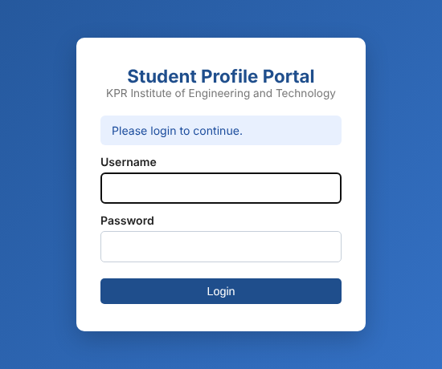
Figure 18: Opening /students without logging in redirects to the login page
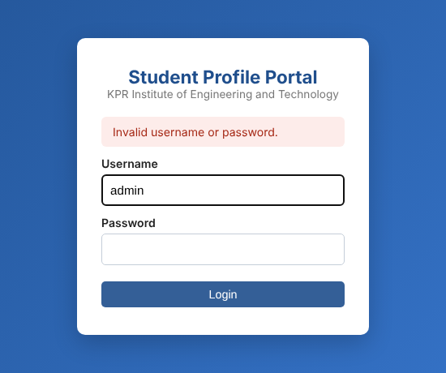
Figure 19: Login with a wrong password
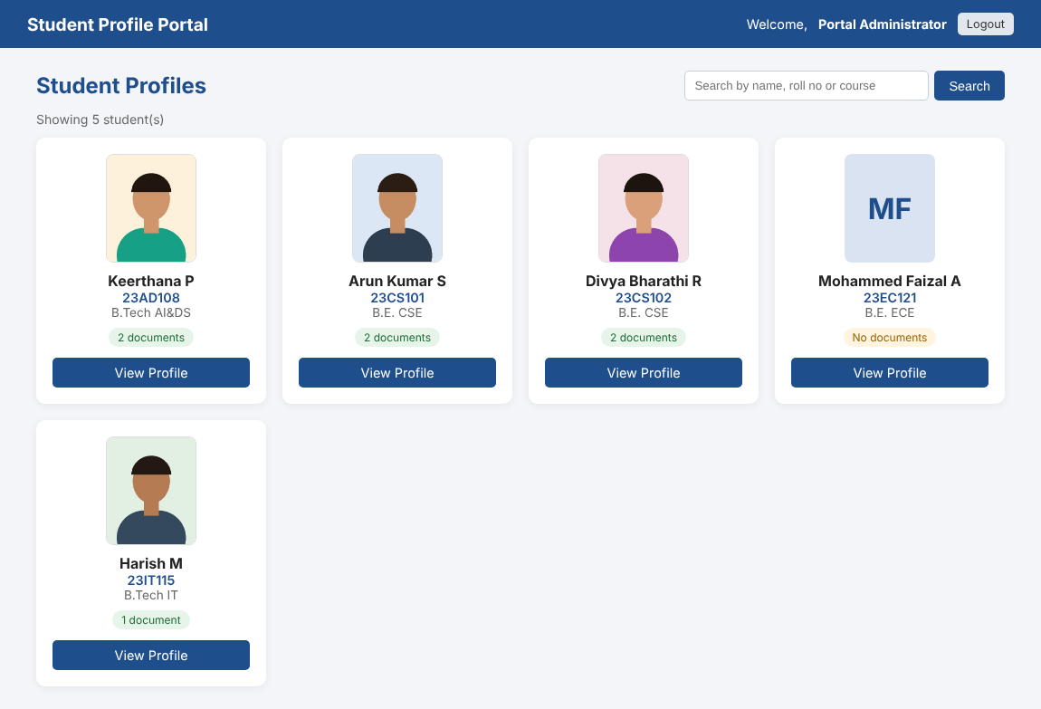
Figure 20: Student list after login (students.jsp). Photos are streamed by FileServlet; 23EC121 has no photo, so initials are shown
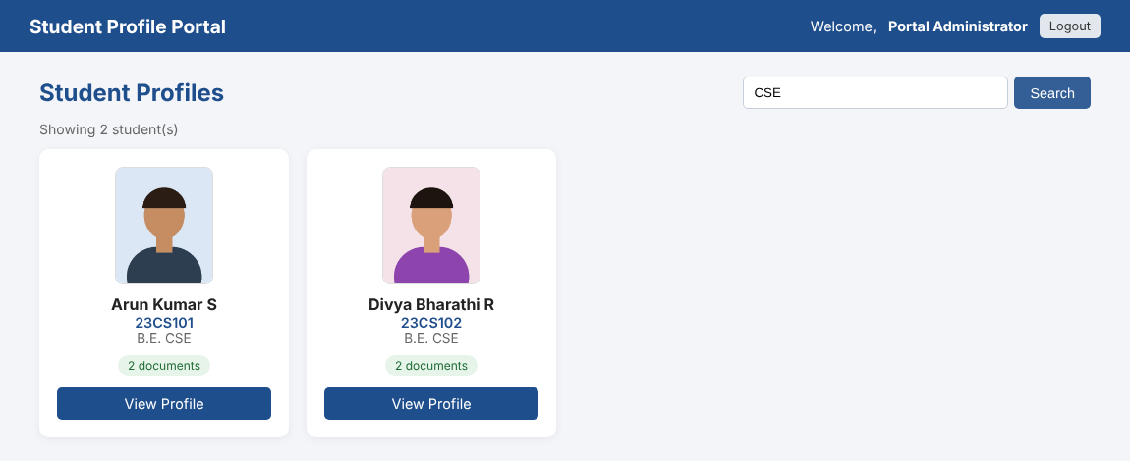
Figure 21: Search result for CSE
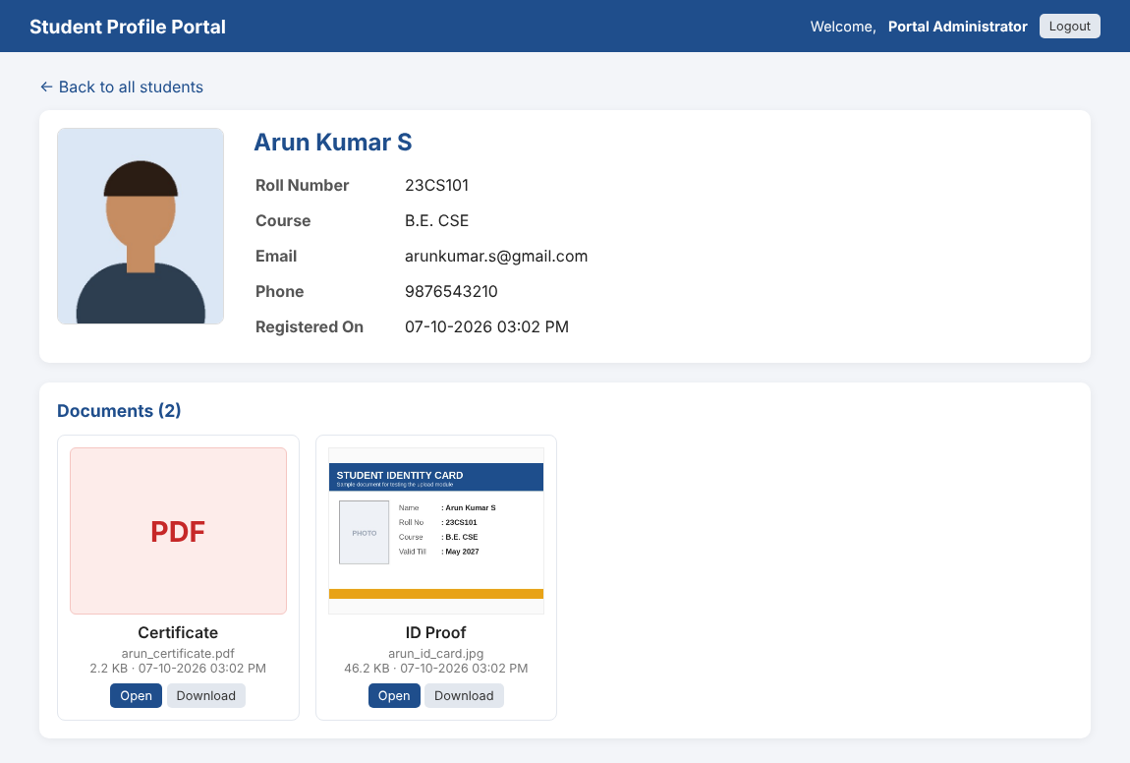
Figure 22: Profile page (profile.jsp) with the ID proof image and the PDF certificate
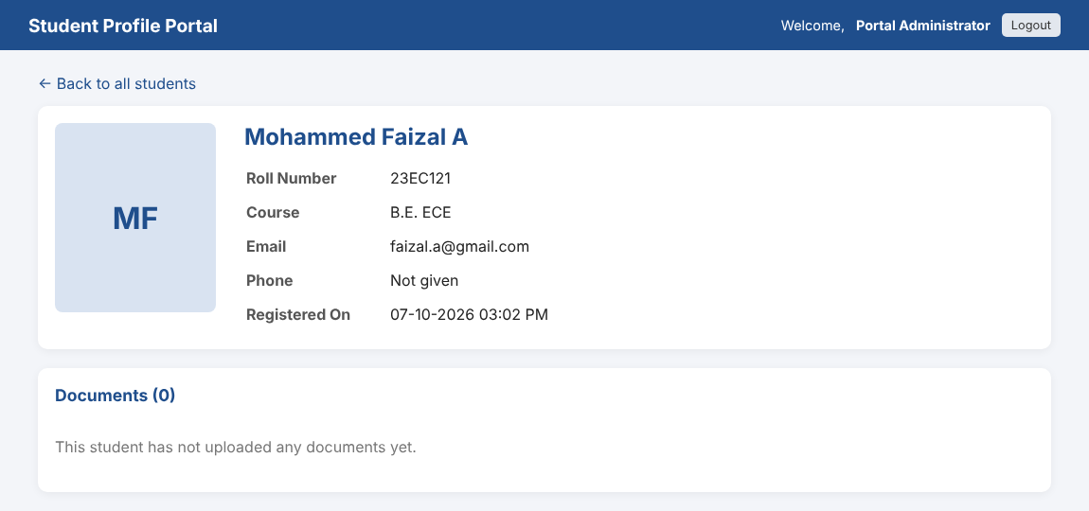
Figure 23: Profile of a student with no photo and no documents
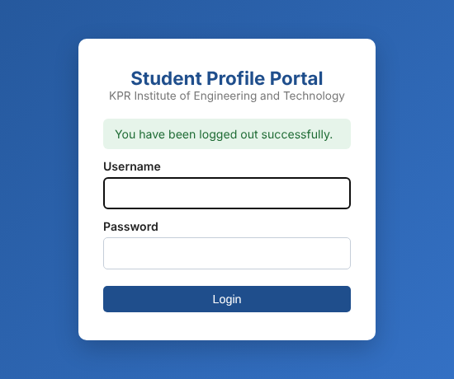
Figure 24: Message after logout

8. Steps to Run the Project

A. Database
- Install XAMPP and start Apache and MySQL from the XAMPP Control Panel.
- Open http://localhost/phpmyadmin, go to the Import tab and import database/college_db.sql (or paste the script in the SQL tab and click Go).

B. Question 1
- Open q1_registration/register.html in Chrome. No server is needed for this part.

C. Question 2
- Copy the q2_admin_php folder to C:\xampp\htdocs\ and rename it to student_admin.
- If the MySQL root user has a password, change DB_PASS in db.php.
- In C:\xampp\php\php.ini check that upload_max_filesize = 10M and post_max_size = 12M, then restart Apache.
- Open http://localhost/student_admin/ in the browser.

D. Question 3
- In Eclipse create a Dynamic Web Project named StudentPortal with Apache Tomcat 10.1 as the target runtime.
- Copy the com.kpr.portal packages into src/main/java and the contents of webapp into src/main/webapp.
- Download MySQL Connector/J (platform independent) from dev.mysql.com and copy mysql-connector-j-x.x.x.jar into src/main/webapp/WEB-INF/lib.
- In web.xml set uploadDirectory to the uploads folder of the PHP project (C:/xampp/htdocs/student_admin/uploads). Use forward slashes.
- Right click the project, choose Run As > Run on Server, open http://localhost:8080/StudentPortal/ and log in with admin / Admin@123.

9. Testing Summary
Table 7: Test cases
No. | Test case | Expected result | Result
1 | Q1: Click Register with an empty form | Message under every required field | Pass
2 | Q1: Roll number CS-101 | Invalid format. Example: 23CS101 | Pass
3 | Q1: Password arun12 | Meter shows Weak, password rejected | Pass
4 | Q1: 6 MB photo / JPG as mark sheet | Size error / PDF only error | Pass
5 | Q1: All valid data | Success message with name and roll number | Pass
6 | Q1: Page width 390 px | Fields stacked in one column | Pass
7 | Q2: Text file renamed to .jpg as photo | Rejected by MIME check, nothing saved | Pass
8 | Q2: 6 MB photo | Rejected by size check | Pass
9 | Q2: Add student with 3 files | Row in students, 3 rows in student_files, files in uploads | Pass
10 | Q2: Same roll number again | Duplicate message, no files left on disk | Pass
11 | Q2: Edit phone and add ID proof | Details updated, new file listed | Pass
12 | Q2: Delete single file | Row and file on disk removed | Pass
13 | Q2: Delete student | Student, file rows (cascade) and files removed | Pass
14 | Q3: Open /students without login | Redirect to login with message | Pass
15 | Q3: Wrong password | Invalid username or password | Pass
16 | Q3: Login as admin | Student cards with photos from FileServlet | Pass
17 | Q3: /file?id=999 | HTTP 404 | Pass
18 | Q3: Open /WEB-INF/views/students.jsp directly | HTTP 404, JSP not reachable | Pass
19 | Q3: Logout and then open /profile?id=3 | Redirect to login | Pass
20 | Q3: Session cookie | JSESSIONID is HttpOnly | Pass

10. GitHub Repository
The complete project, with all PHP files, Servlet and WEB-INF files, HTML, CSS and JavaScript files and the database script, is uploaded to GitHub:
Repository link: https://github.com/<your-username>/web-technology-assignment-2

11. Conclusion
This assignment helped me understand how a complete web application works, from a form in the browser to the database and back to the screen. Building the same idea of showing uploaded files in both PHP and Java Servlets showed me how each one handles uploads, sessions and database access. I also learnt that checks done in JavaScript are only for the user's convenience and every important check has to be repeated on the server. In future the project can be extended with role based access for staff and email verification during registration.

